Flute Concert Bb Chromatic One Octave
Quarter Notes #420
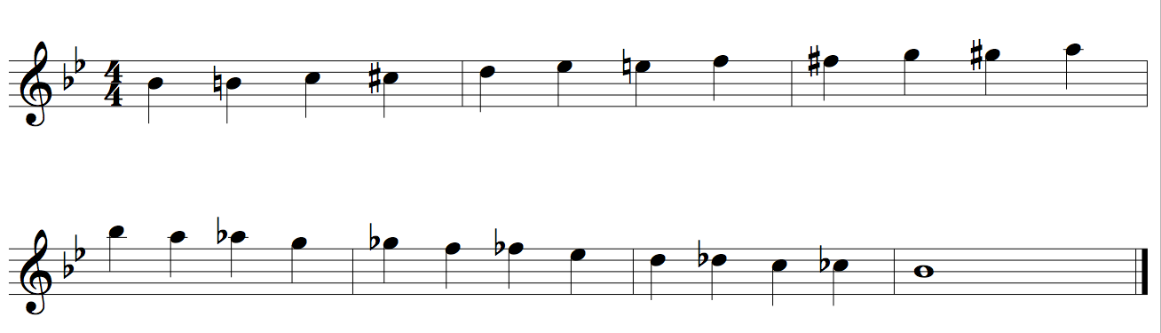

Flute Chromatic Two Octaves
Quarter Notes #422

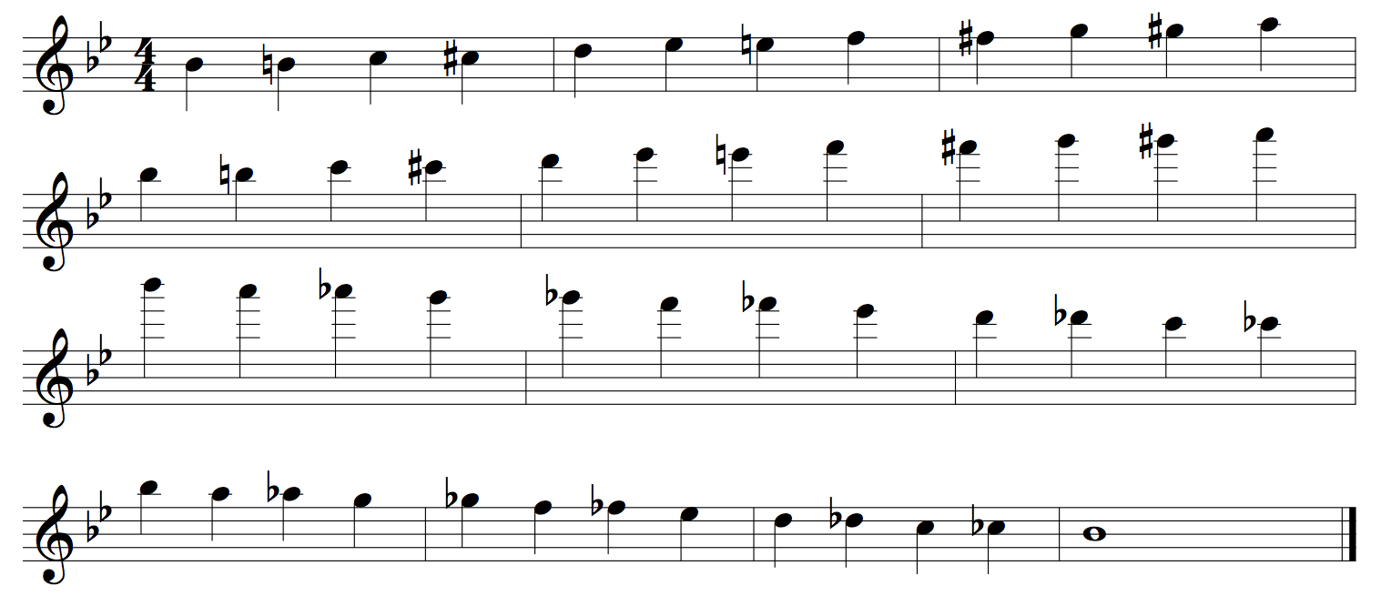

Flute Concert Bb Scale Two Octaves
Quarter Notes #24

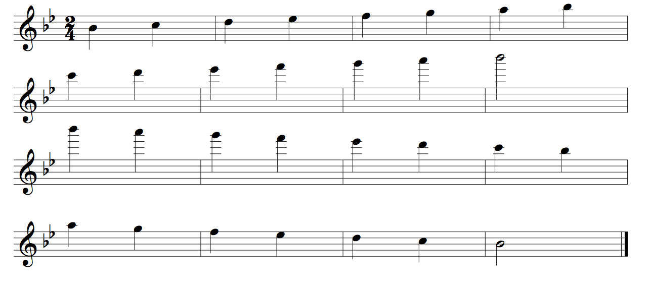

Flute Concert Eb Scale Two Octaves
Quarter Notes #24
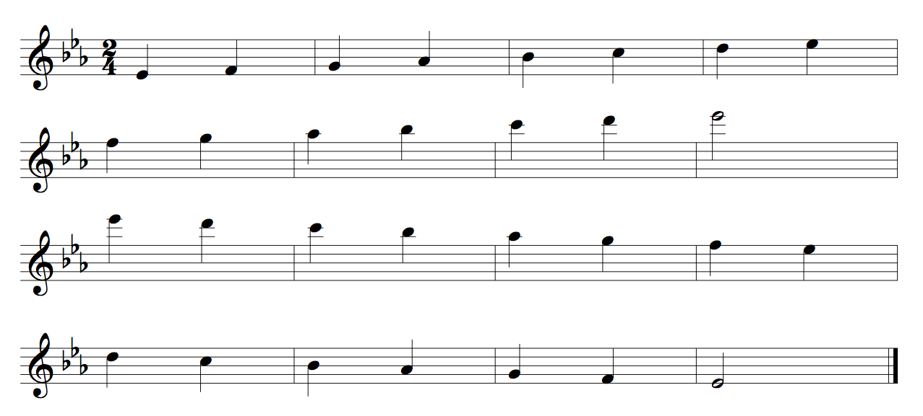

Flute Concert Ab Scale Two Octaves
Quarter Notes #24
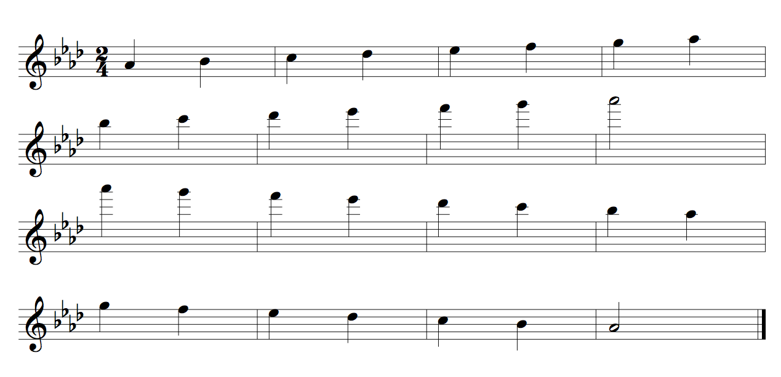
Flute Concert Db Scale Two Octaves
Quarter Notes #24
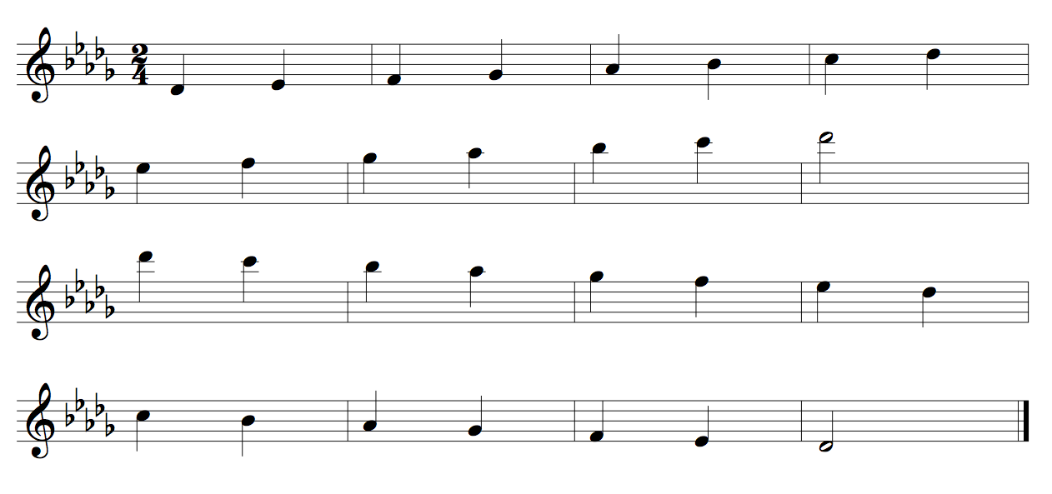

Flute Concert Gb Scale Two Octaves
Quarter Notes #24
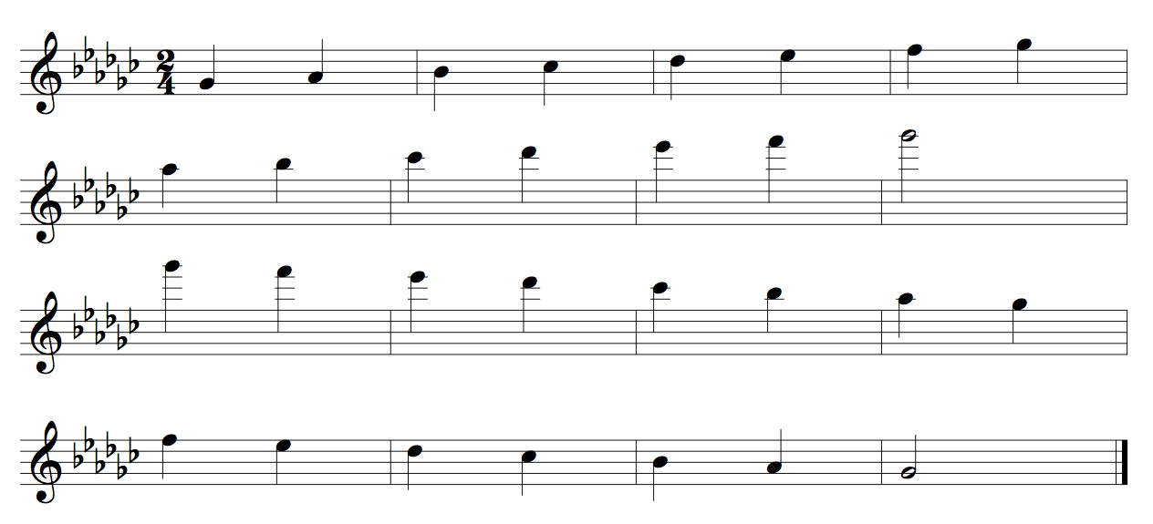

Flute Concert B Scale Two Octaves
Quarter Notes #24
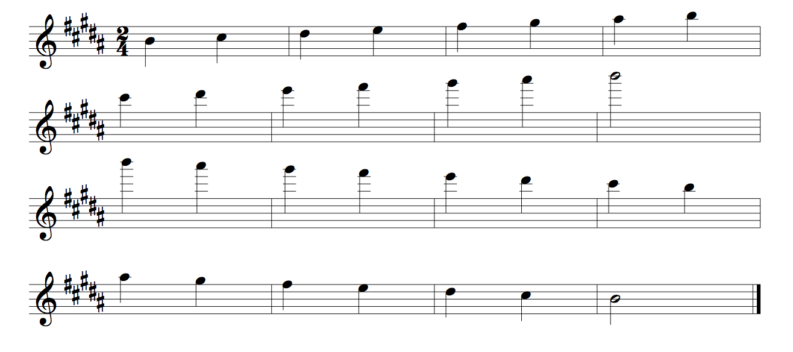
Flute Concert E Scale Two Octaves
Quarter Notes #24
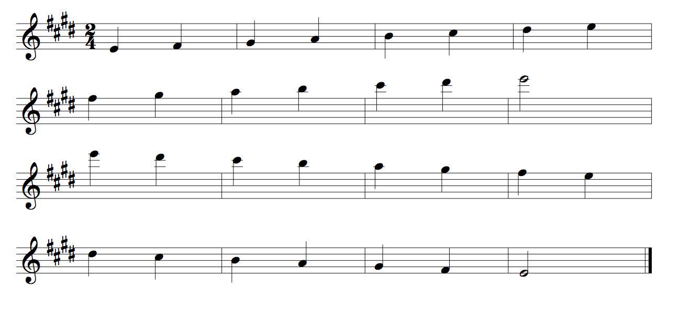
Flute Concert A Scale Two Octaves
Quarter Notes #24
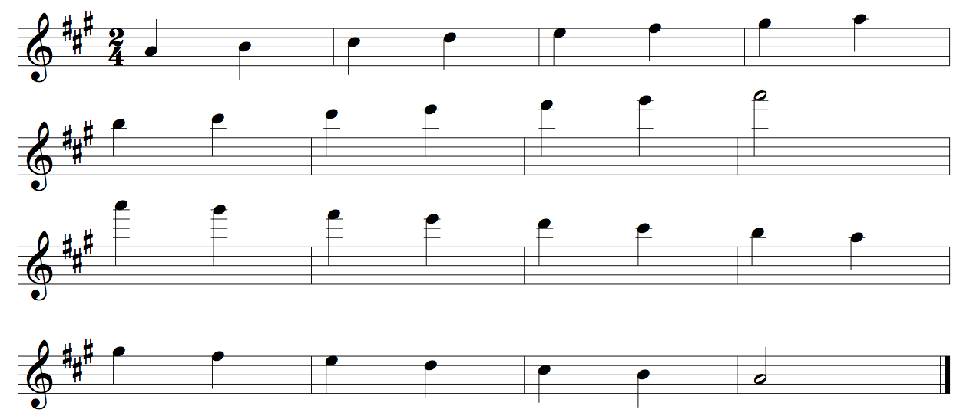
Flute Concert D Scale Two Octaves
Quarter Notes #24
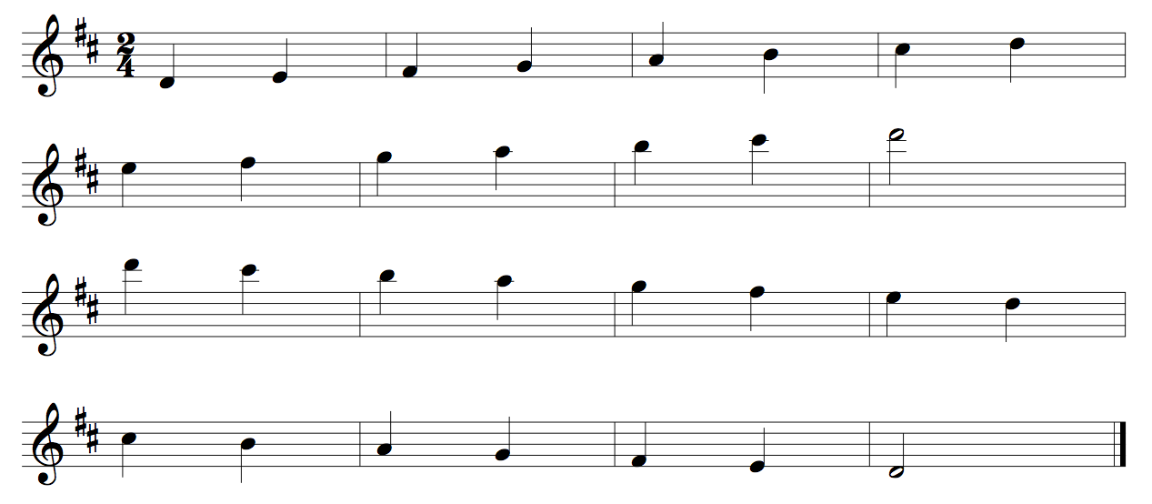
Flute Concert G Scale Two Octaves
Quarter Notes #24
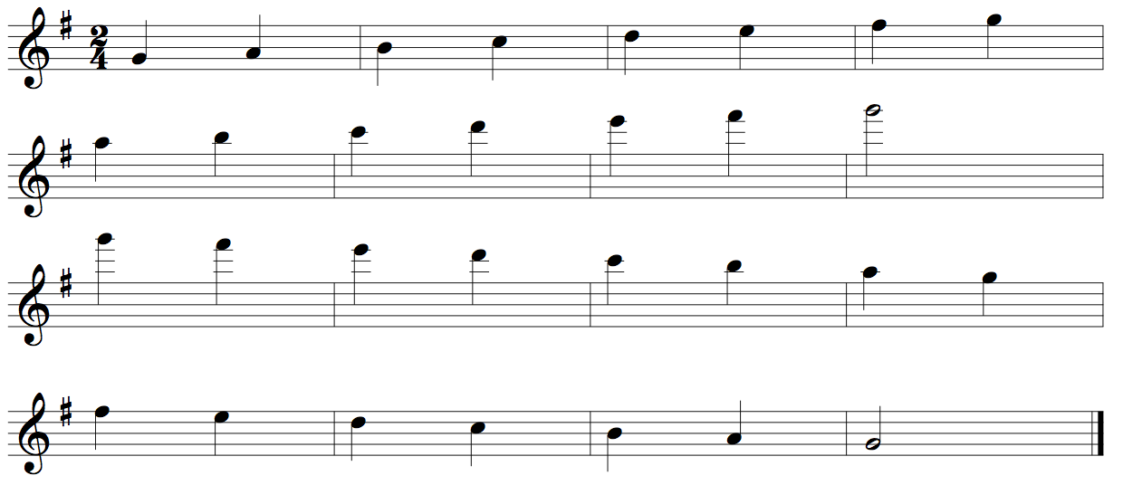

Flute Concert C Scale Two Octaves
Quarter Notes #24
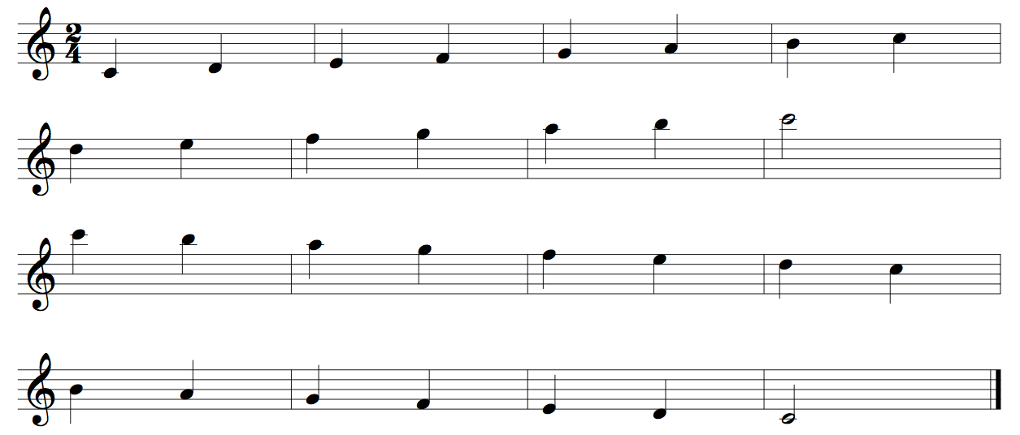
Flute Concert F Scale Two Octaves
Quarter Notes #24

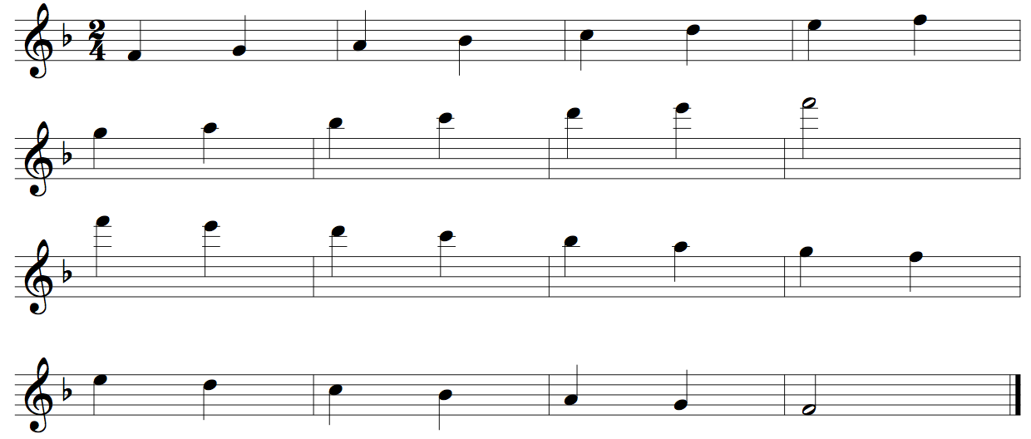

Oboe Concert Bb Chromatic One Octave
Quarter Notes #420

Oboe Concert Bb Chromatic Two Octaves
Quarter Notes #422

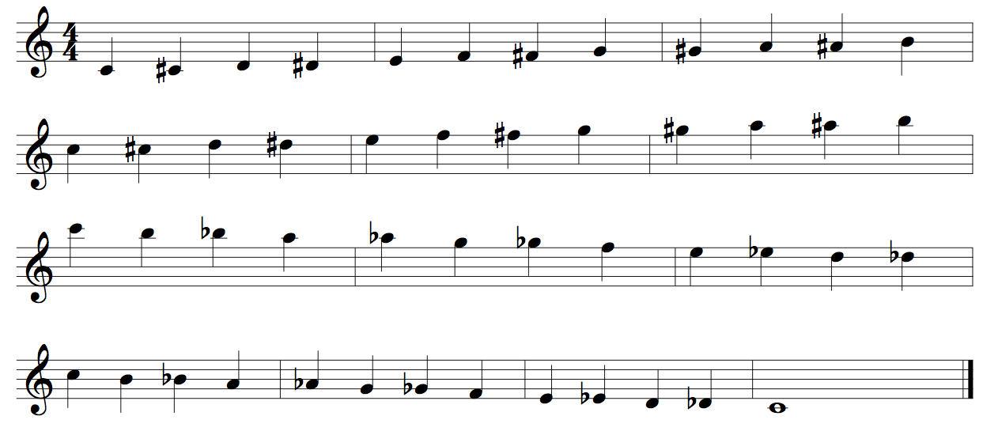

Oboe Concert Bb Scale Two Octaves
Quarter Notes #24
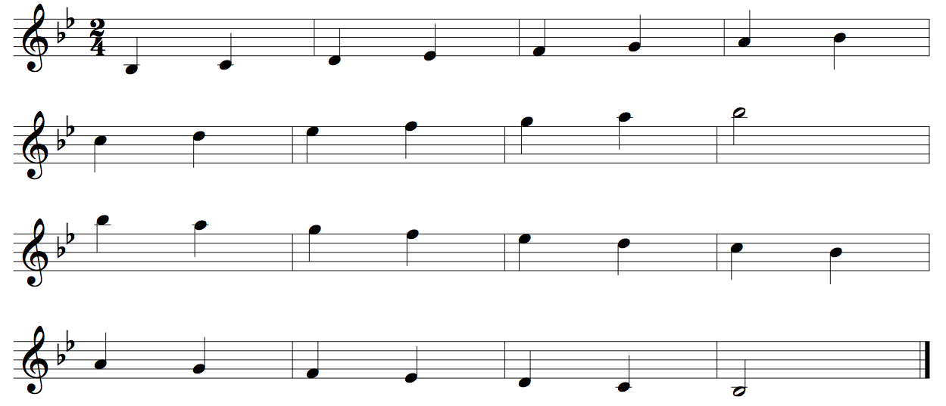

Oboe Concert Eb Scale Two Octaves
Quarter Notes #24
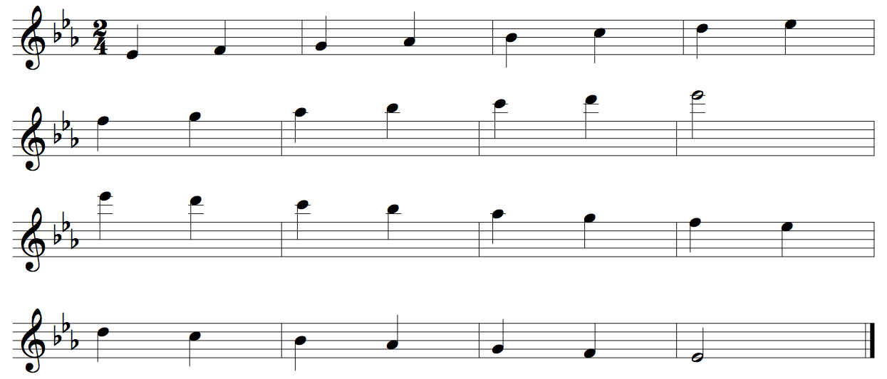
Oboe Concert Ab Scale Two Octaves
Quarter Notes #24
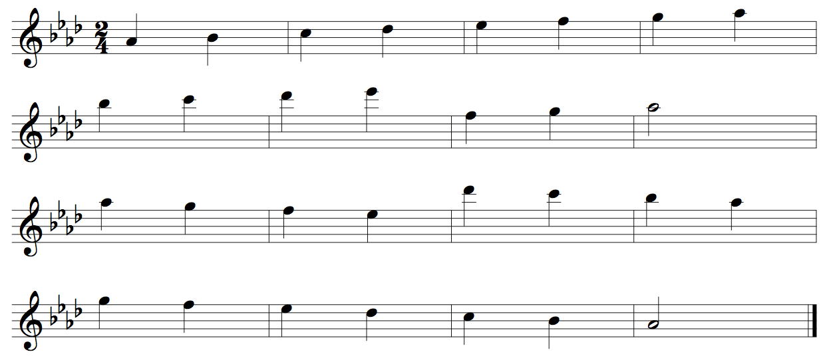
Oboe Concert Db Scale Two Octaves
Quarter Notes #24
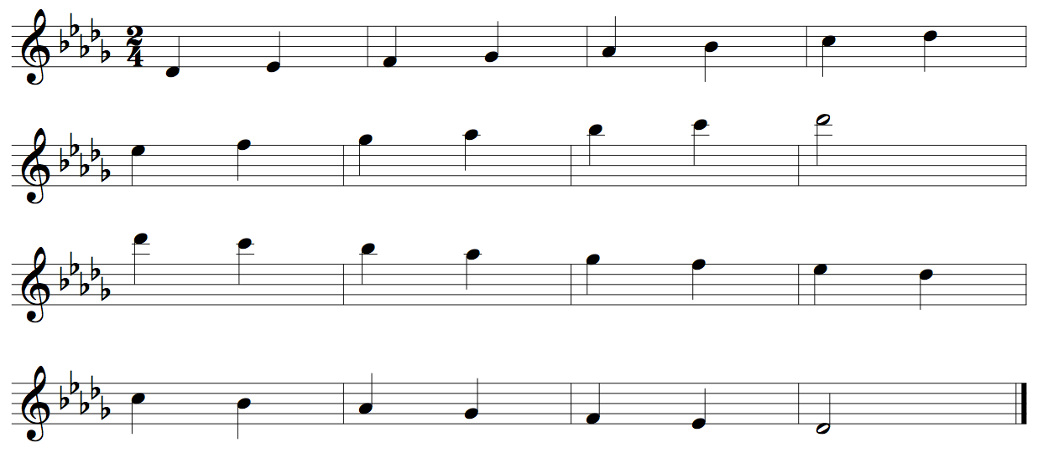

Oboe Concert Gb Scale Two Octaves
Quarter Notes #24
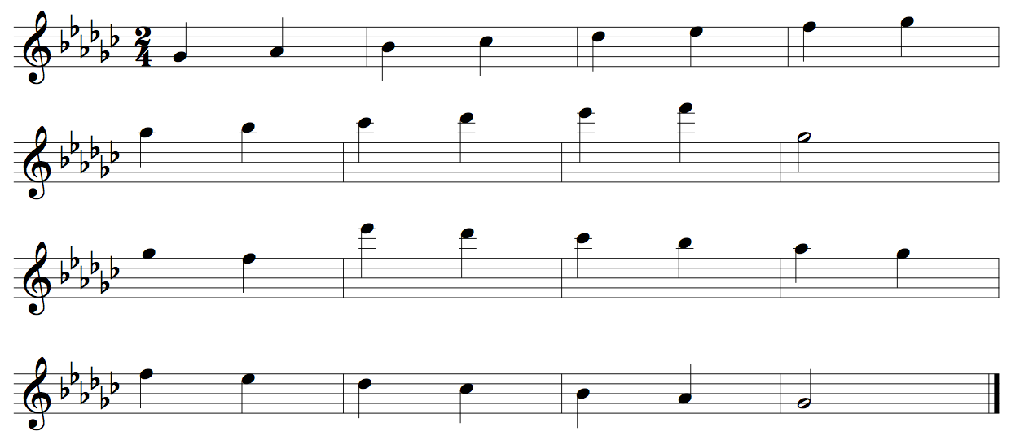
Oboe Concert B Scale Two Octaves
Quarter Notes #24
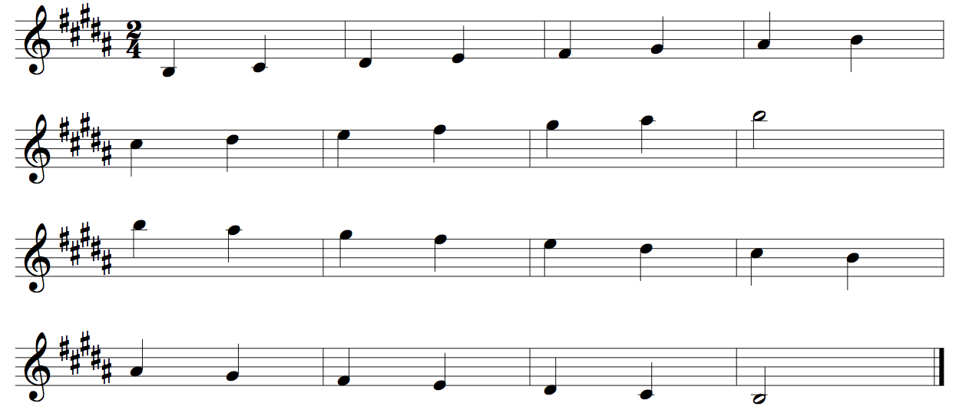

Oboe Concert E Scale Two Octaves
Quarter Notes #24
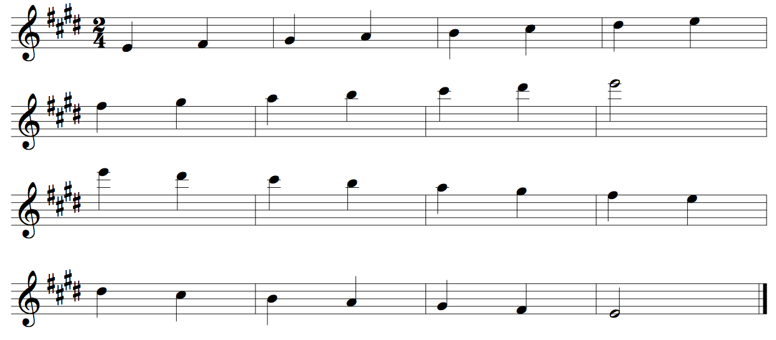
Oboe Concert A Scale Two Octaves
Quarter Notes #24
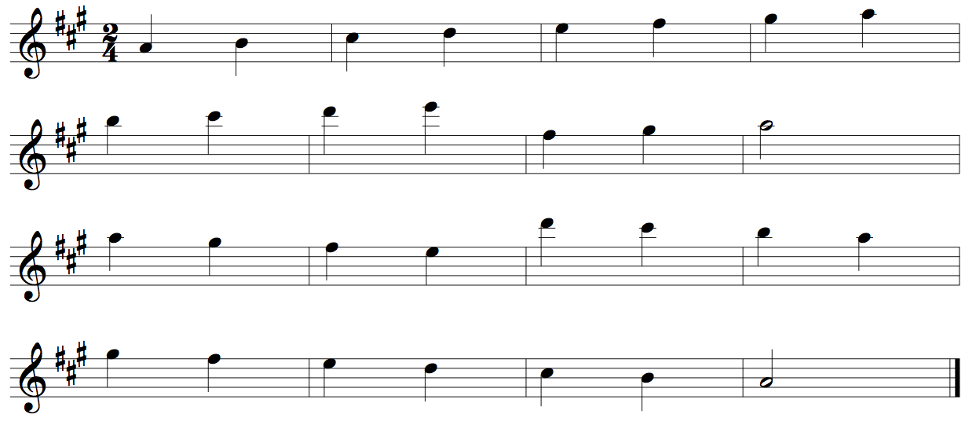

Oboe Concert D Scale Two Octaves
Quarter Notes #24
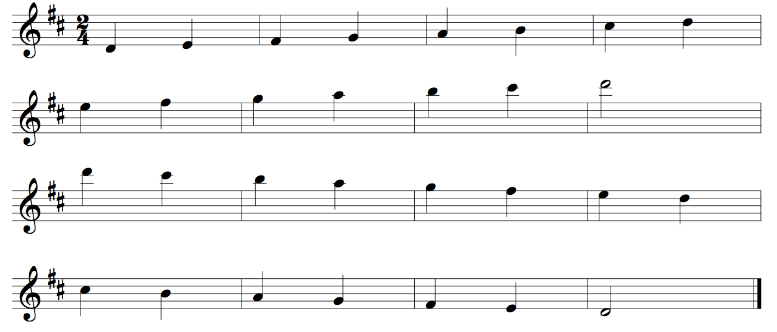
Oboe G Scale Two Octaves
Quarter Notes #24
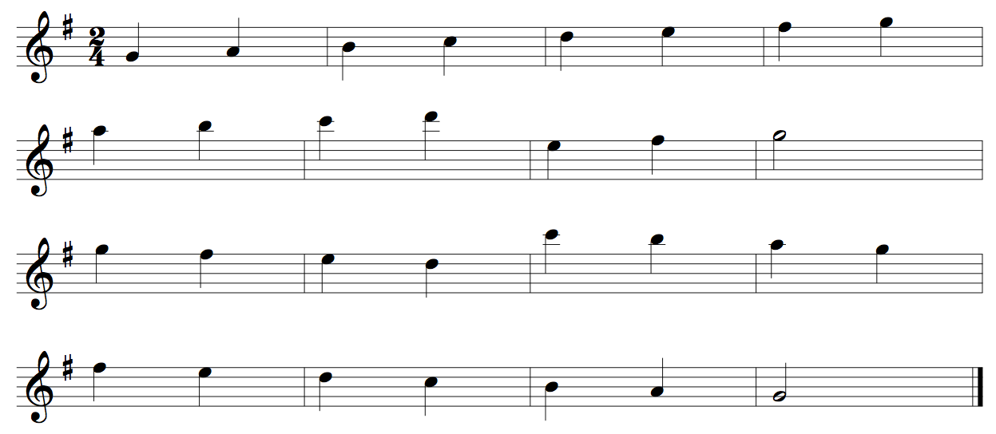
Oboe Concert C Scale Two Octaves
Quarter Notes #24
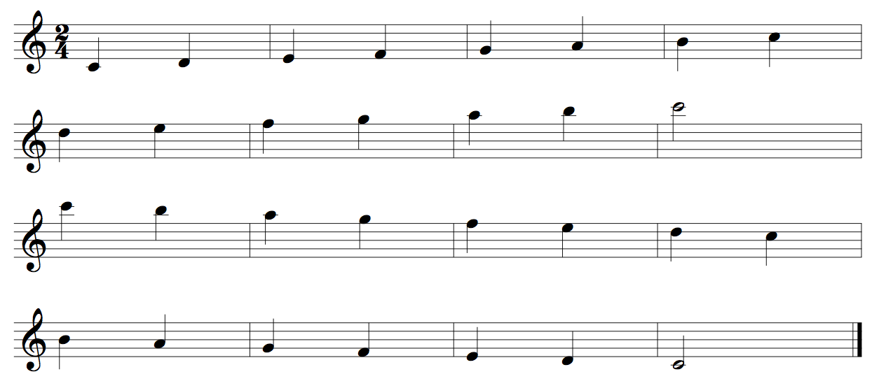
Oboe Concert F Scale Two Octaves
Quarter Notes #24
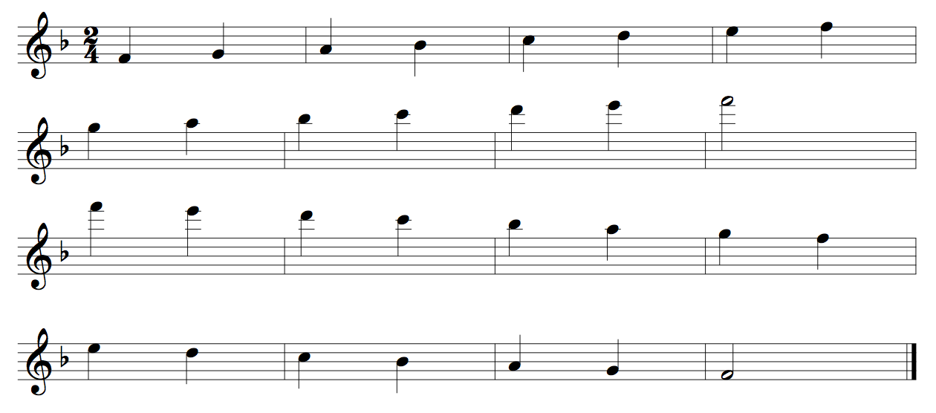

Clarinet Concert Bb Chromatic One Octave
Quarter Notes #420
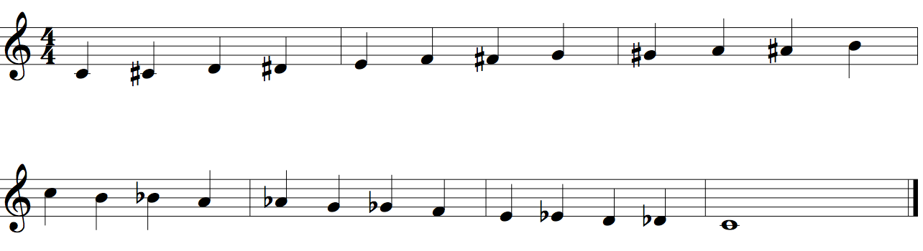
Clarinet Concert Bb Chromatic Two Octaves
Quarter Notes #422

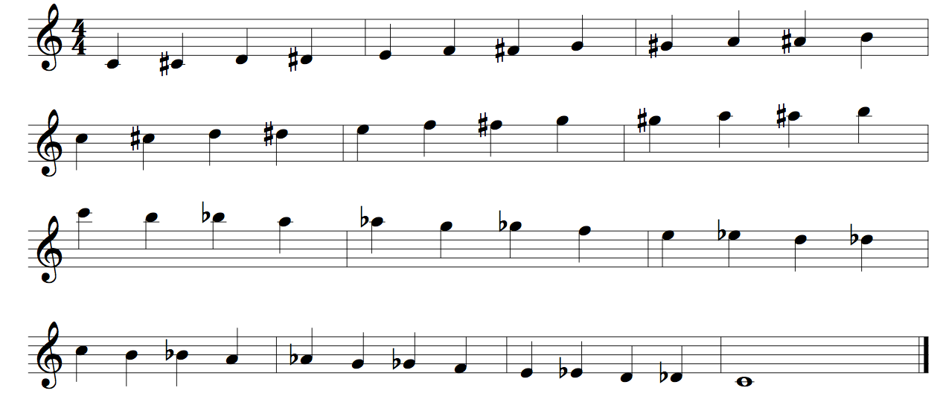

Clarinet Concert Bb Scale Two Octaves
Quarter Notes #24
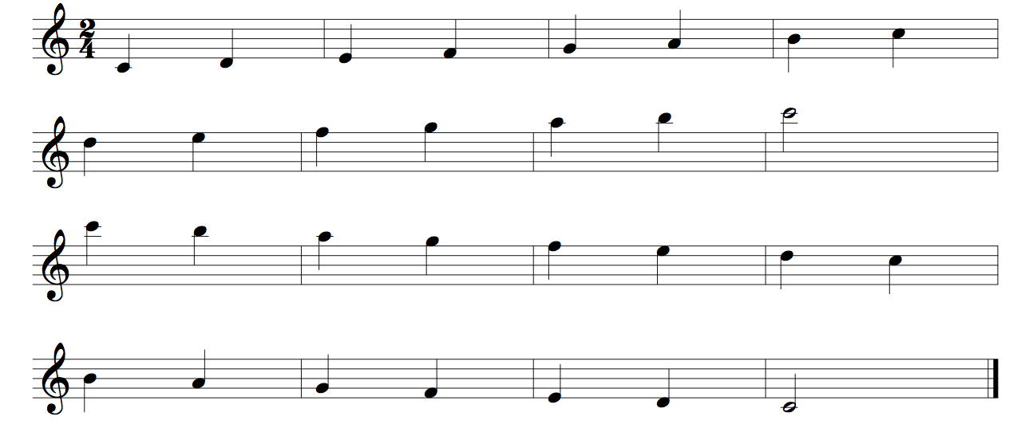

Clarinet Concert Eb Scale Two Octaves
Quarter Notes #24
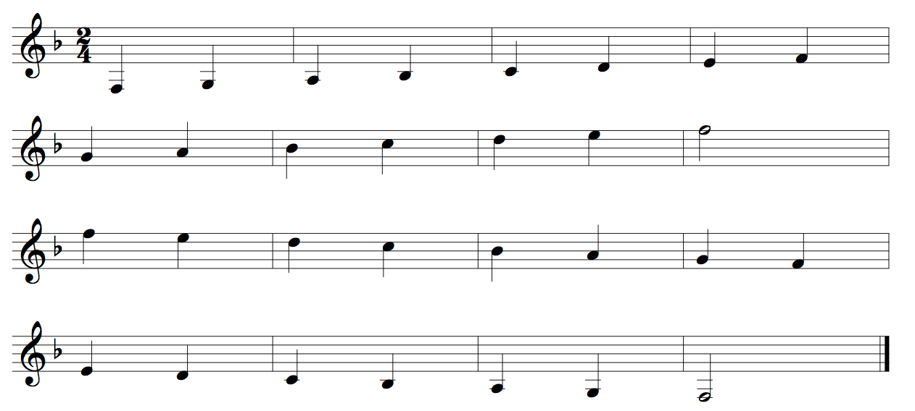
Clarinet Concert Ab Scale Two Octaves
Quarter Notes #24
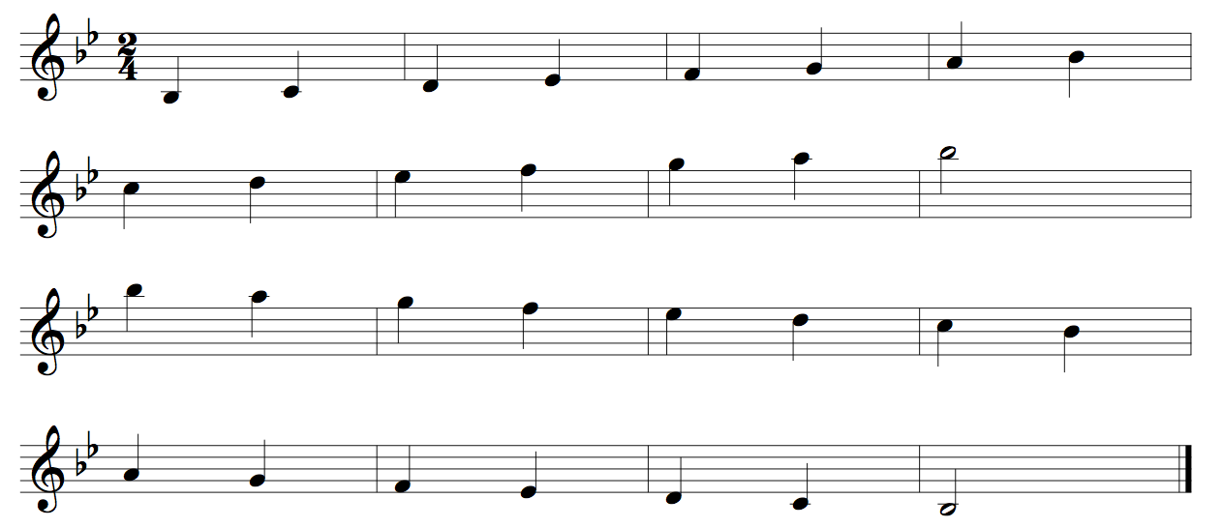
Clarinet Concert Db Scale Two Octaves
Quarter Notes #24
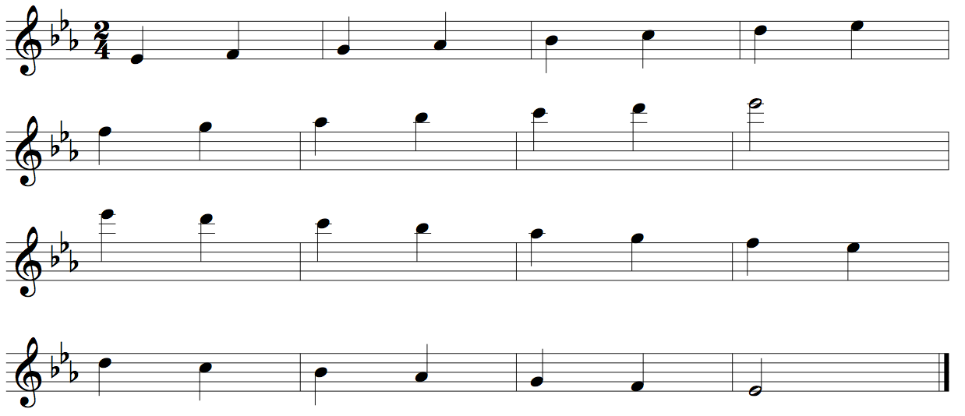
Clarinet Concert Gb Scale Two Octaves
Quarter Notes #24
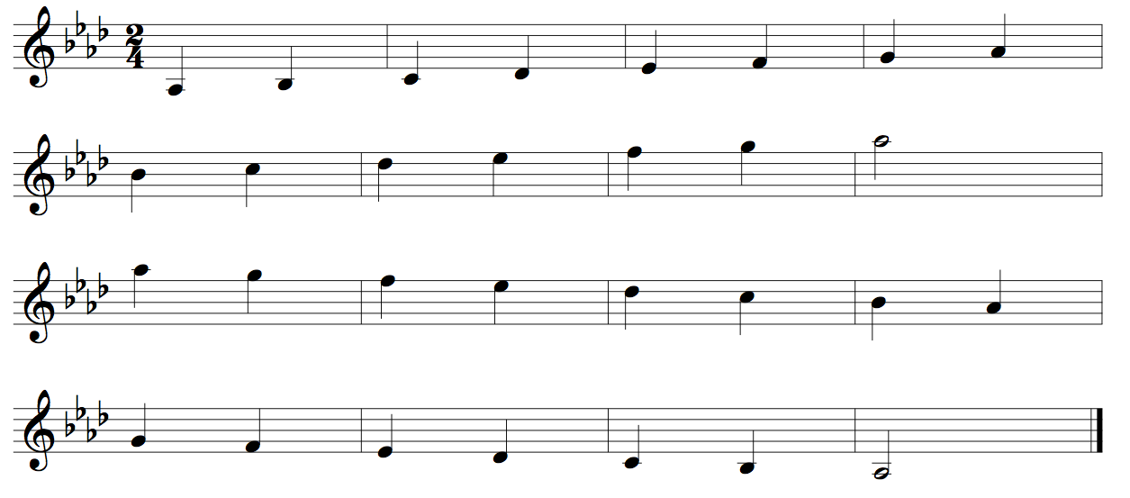
Clarinet Concert Cb Scale Two Octaves
Quarter Notes# 24
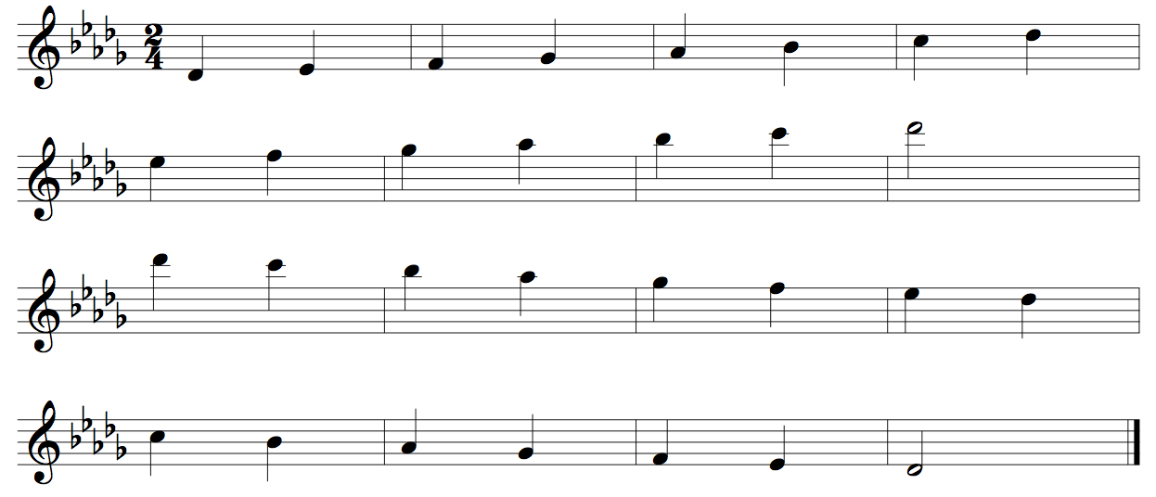
Clarinet Concert Fb Scale Two Octaves
Quarter Notes #24
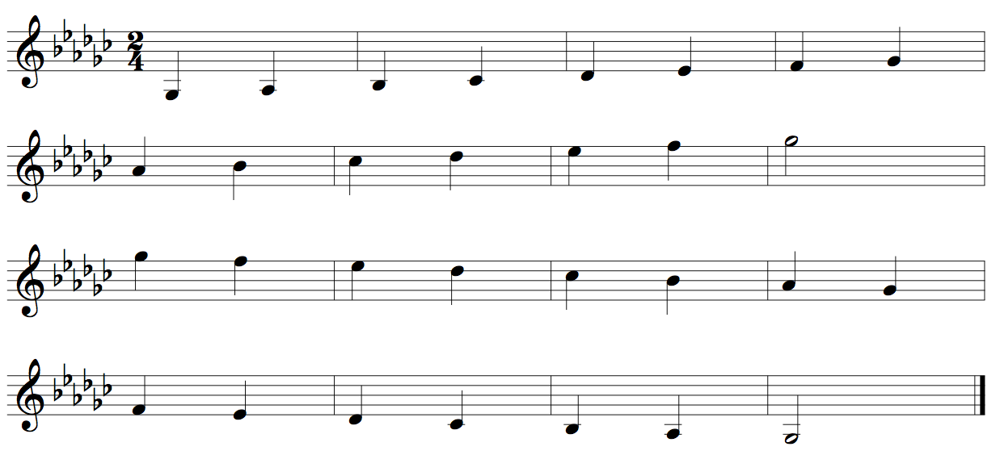
Clarinet Concert A Scale Two Octaves
Quarter Notes #24
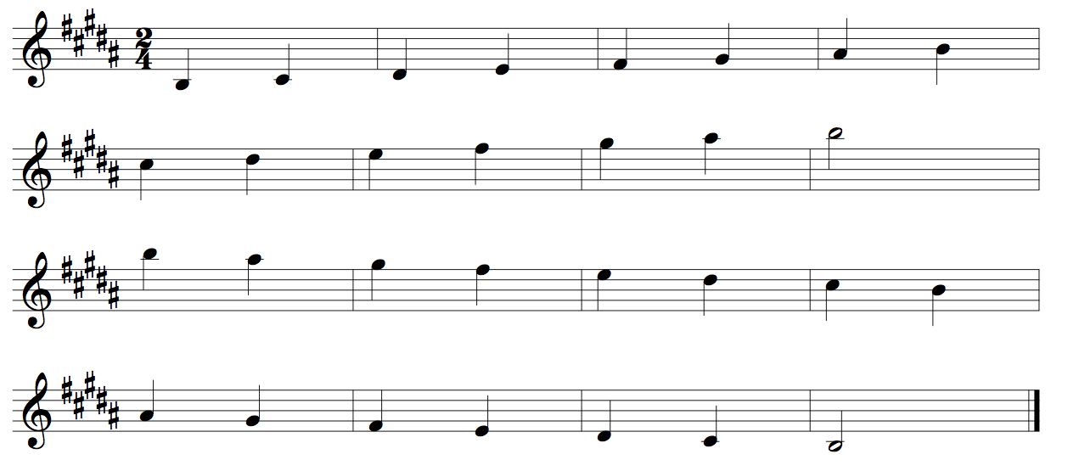
Clarinet Concert D Scale Two Octaves
Quarter Notes #24
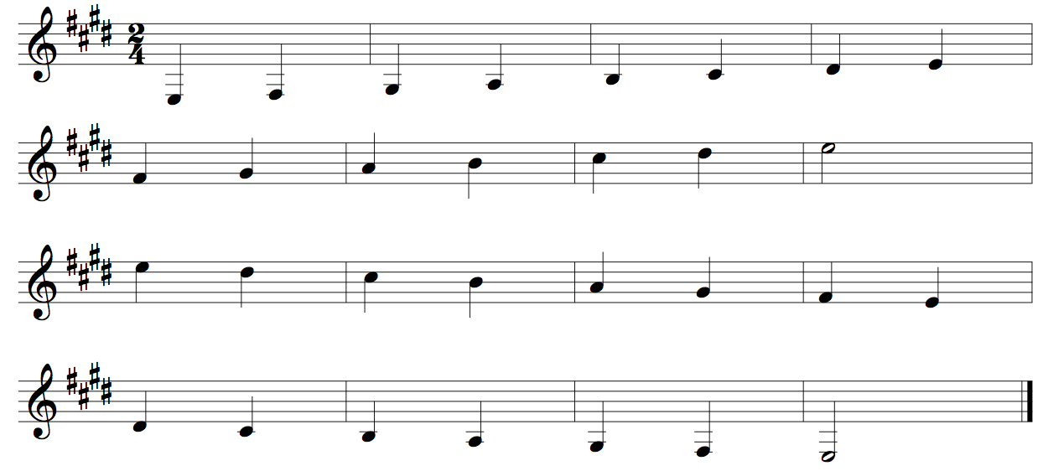
Clarinet Concert G Scale Two Octaves
Quarter Notes #24
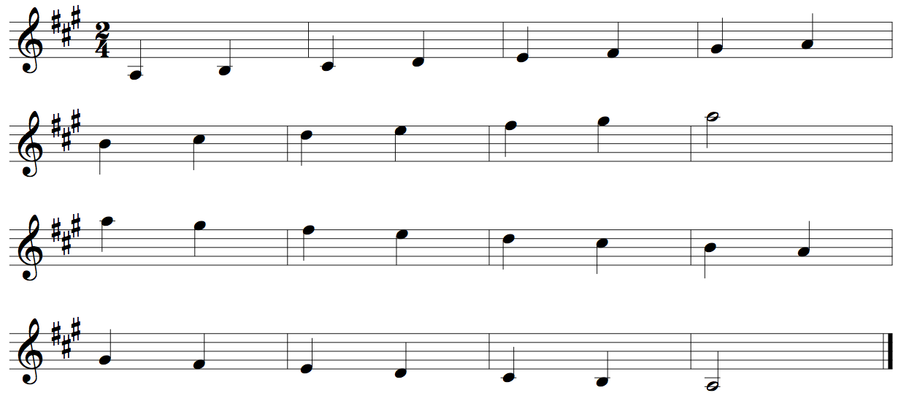
Clarinet Concert C Scale Two Octaves
Quarter Notes #24
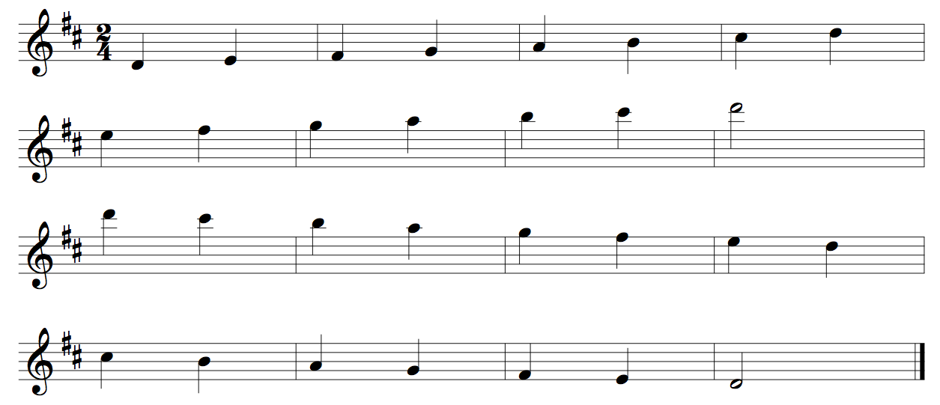
Clarinet Concert F Scale Two Octaves
Quarter Notes #24
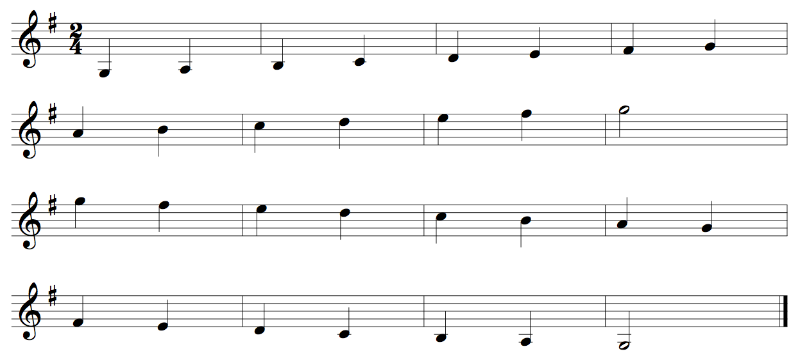

Alto/Bari Saxophone Concert Bb Chromatic One Octave
Quarter Notes #420
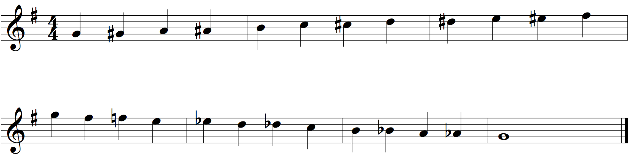
Alto/Bari Saxophone Concert Bb Chromatic Two Octaves
Quarter Notes #422

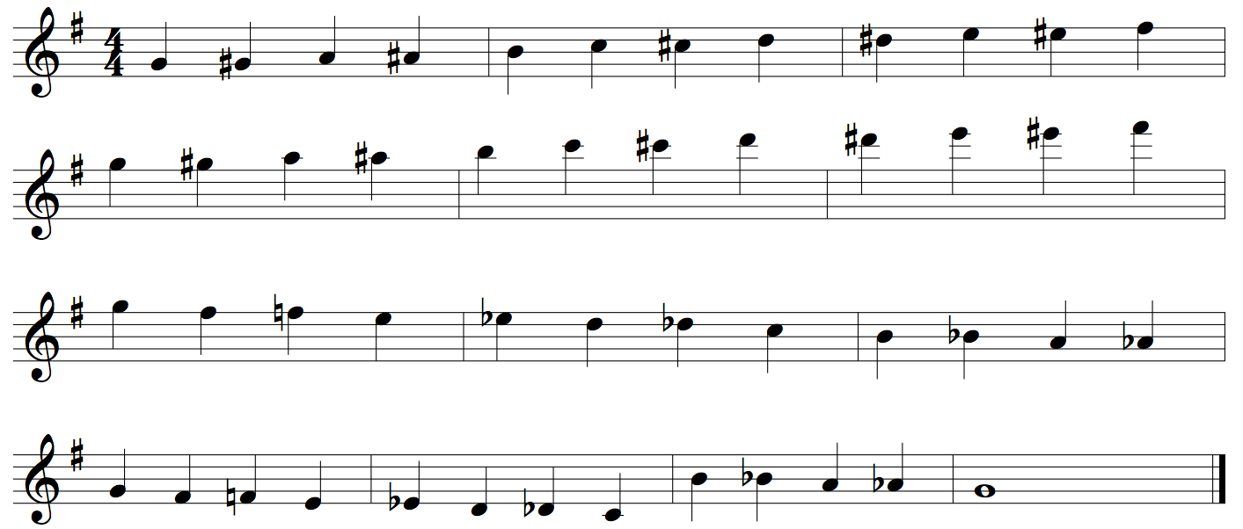

Alto/Bari Saxophone Concert Bb Scale Two Octaves
Quarter Notes #24
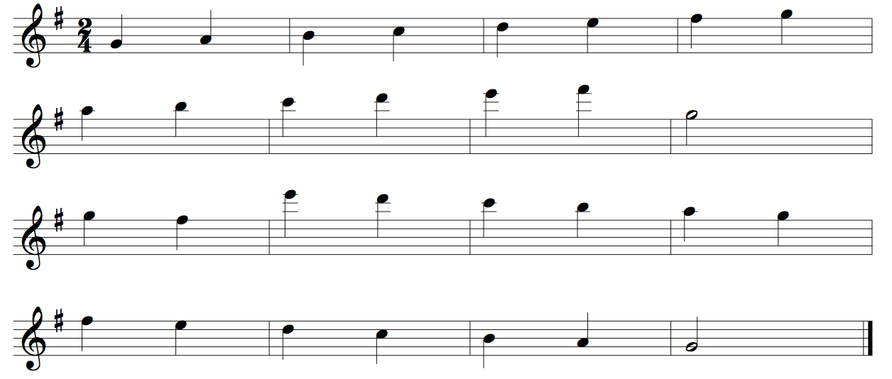

Alto/Bari Saxophone Concert Eb Scale Two Octaves
Quarter Notes #24
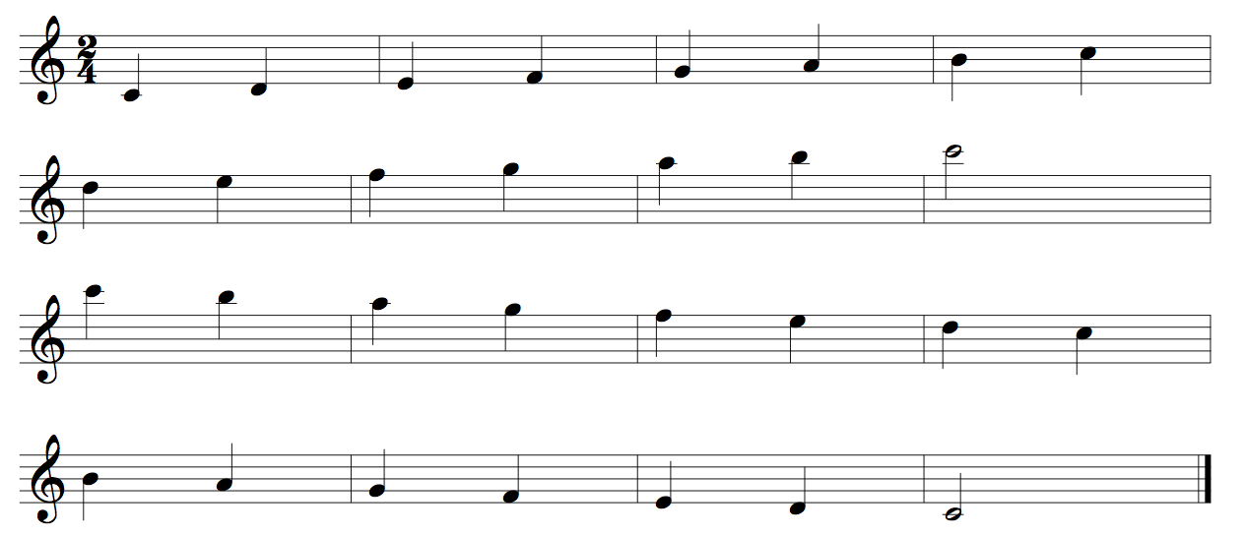
Alto/Bari Saxophone Concert Ab Scale Two Octaves
Quarter Notes #24
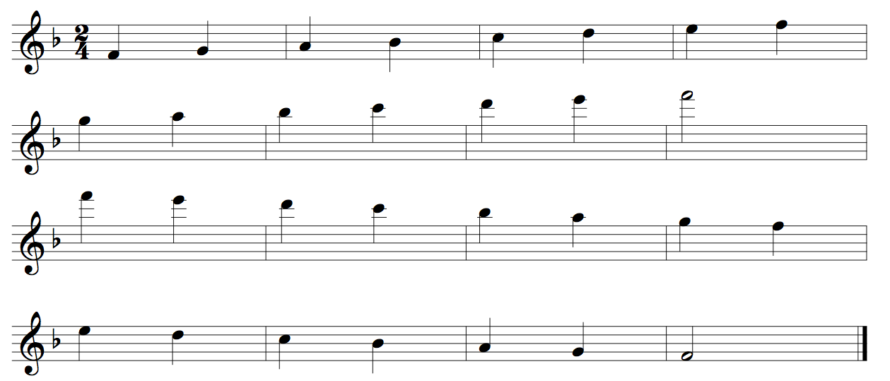
Alto/Bari Saxophone Concert Db Scale Two Octaves
Quarter Notes #24
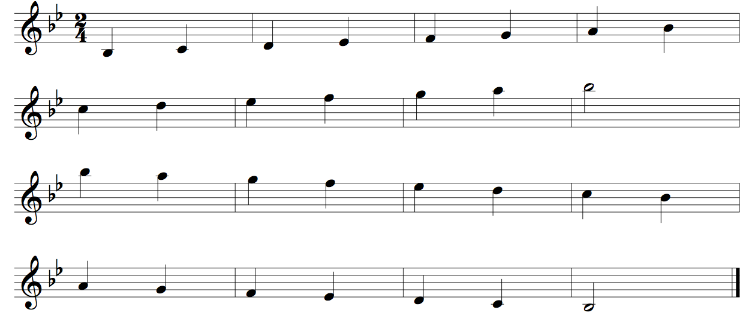

Alto/Bari Saxophone Concert Gb Scale Two Octaves
Quarter Notes #24
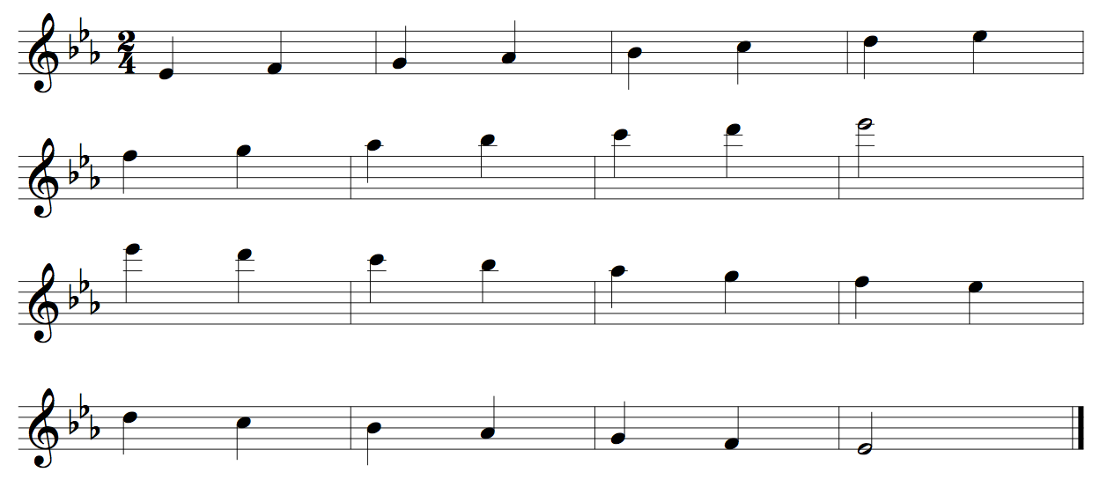
Alto/Bari Saxophone Concert Cb Scale Two Octaves
Quarter Notes #24
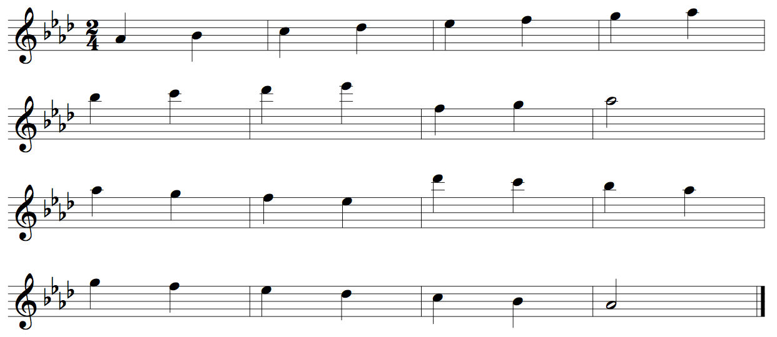
Alto/Bari Saxophone Concert E Scale Two Octaves
Quarter Notes #24
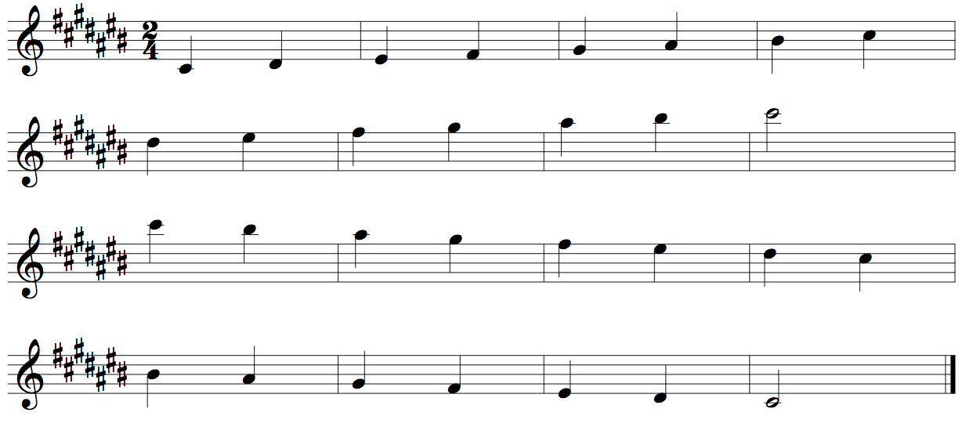
Alto/Bari Saxophone Concert A Scale Two Octaves
Quarter Notes #24
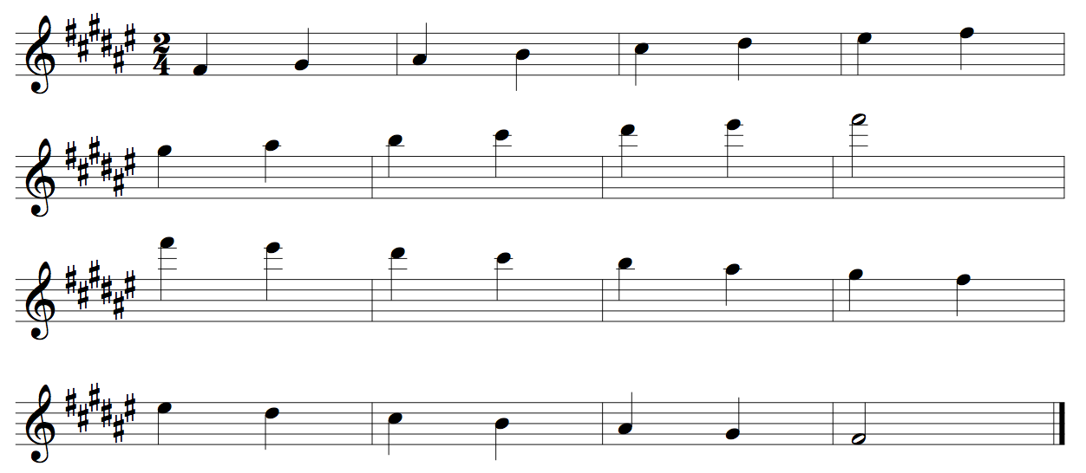
Alto/Bari Saxophone Concert D Scale Two Octaves
Quarter Notes #24
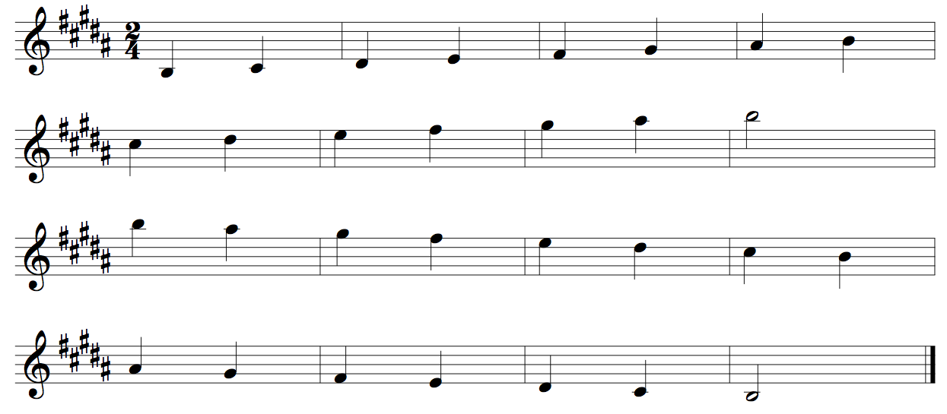
Alto/Bari Saxophone Concert G Scale Two Octaves
Quarter Notes #24
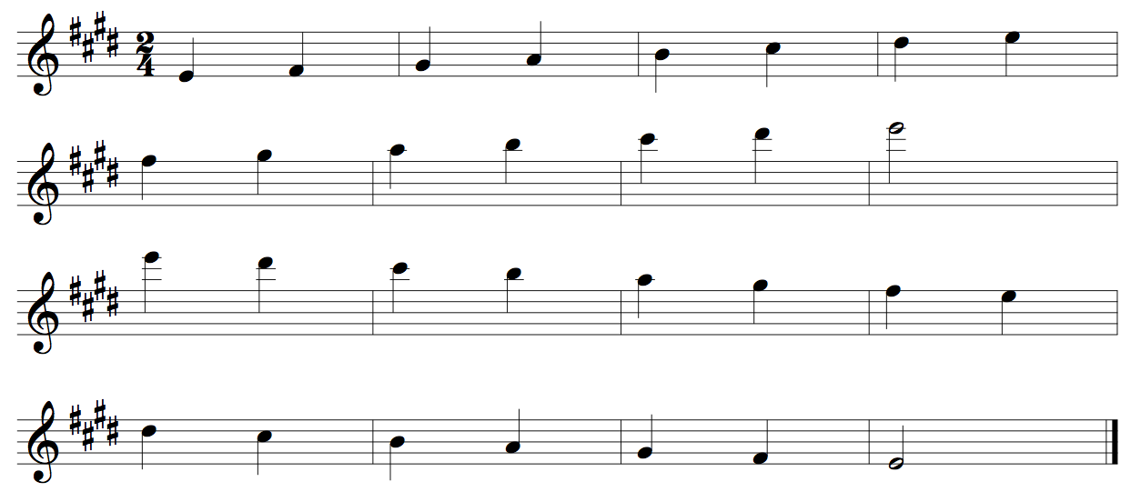

Alto/Bari Saxophone Concert C Scale Two Octaves
Quarter Notes #24
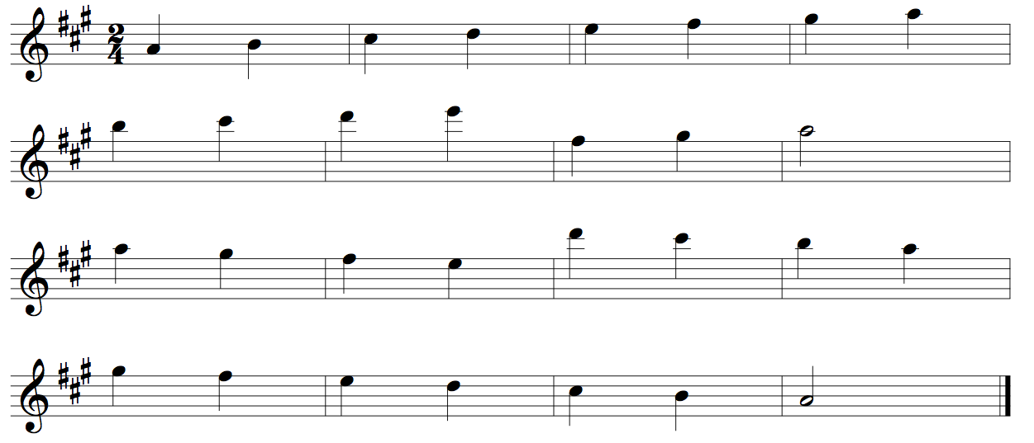
Alto/Bari Saxophone Concert F Scale Two Octaves
Quarter Notes #24

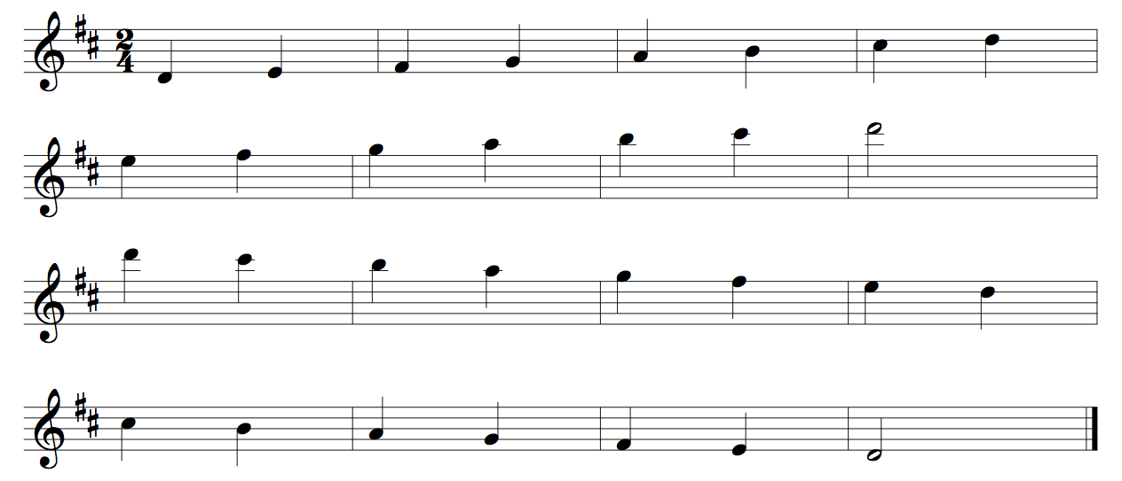

Tenor Saxophone Concert Bb Chromatic One Octave
Quarter Notes #420
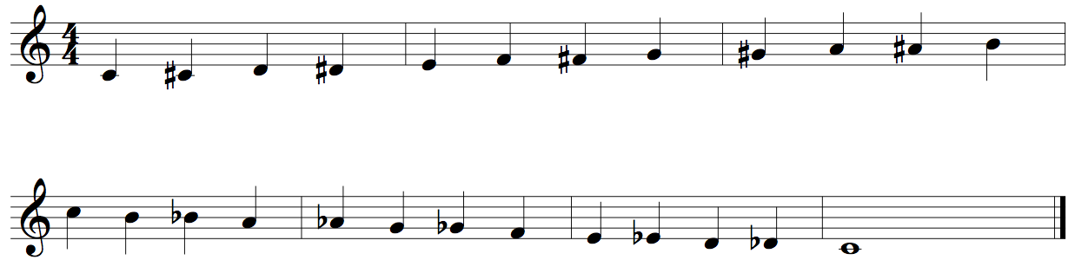
Tenor Saxophone Concert Bb Chromatic Two Octaves
Quarter Notes #422
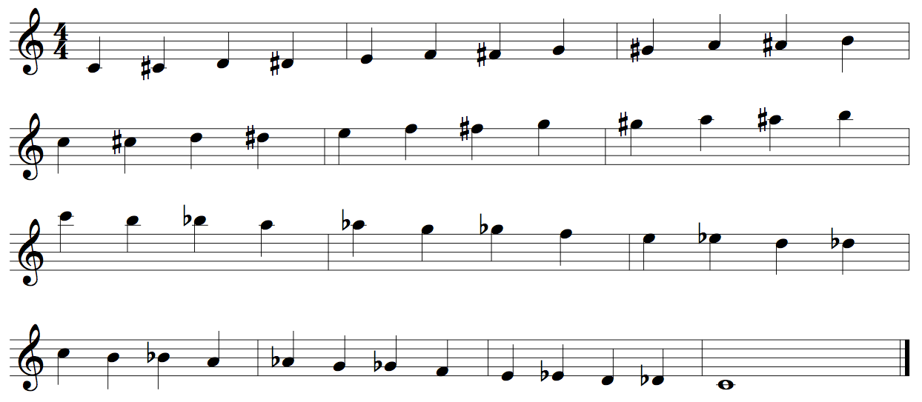

Tenor Saxophone Concert Bb Scale Two Octaves
Quarter Notes #24
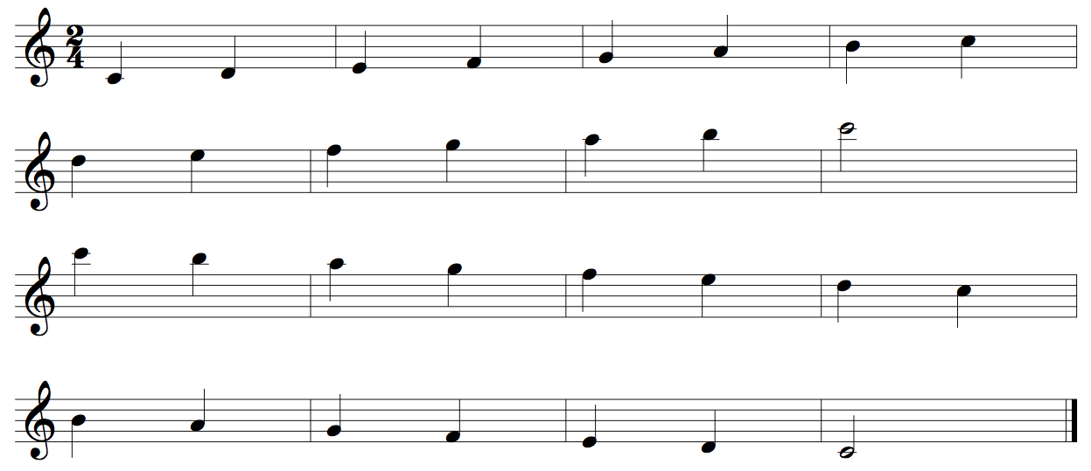

Tenor Saxophone Concert Eb Scale Two Octaves
Quarter Notes #24
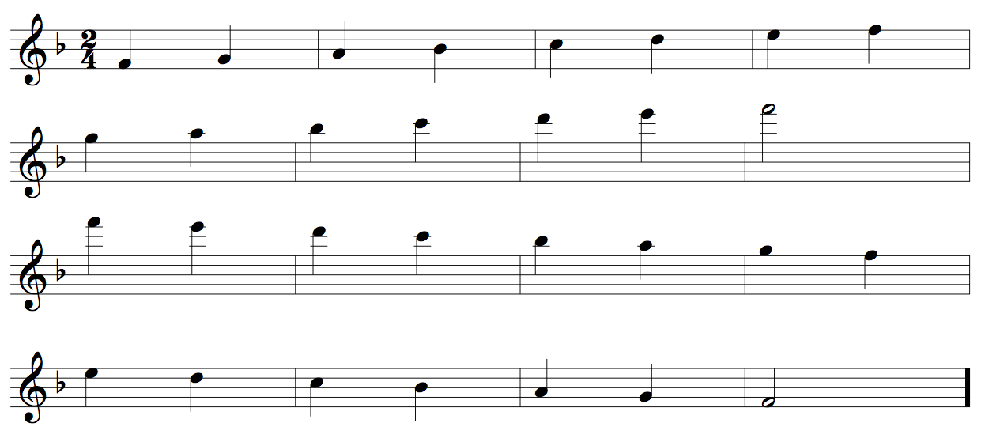
Tenor Saxophone Concert Ab Scale Two Octaves
Quarter Notes #24
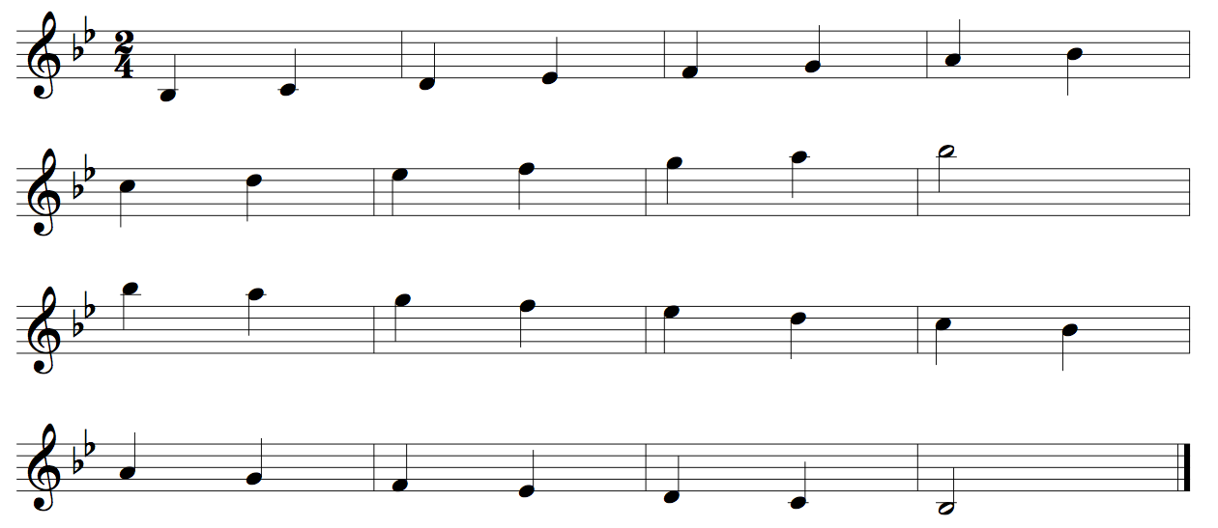
Tenor Saxophone Concert Db Scale Two Octaves
Quarter Notes #24
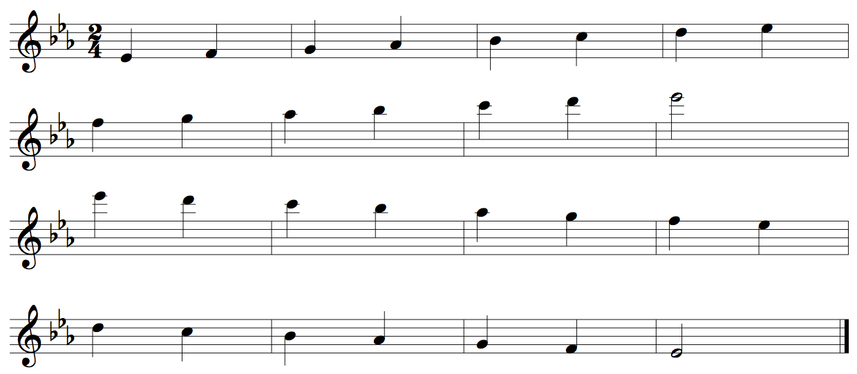

Tenor Saxophone Concert Gb Scale Two Octaves
Quarter Notes #24
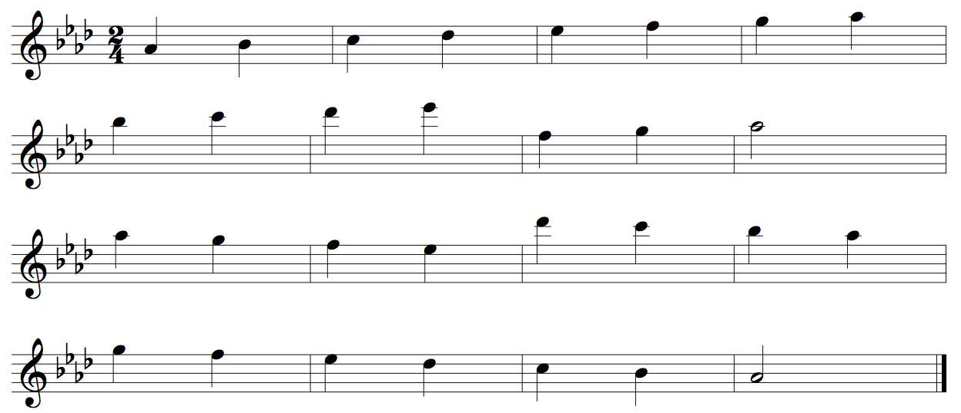
Tenor Saxophone Concert B Scale Two Octaves
Quarter Notes #24
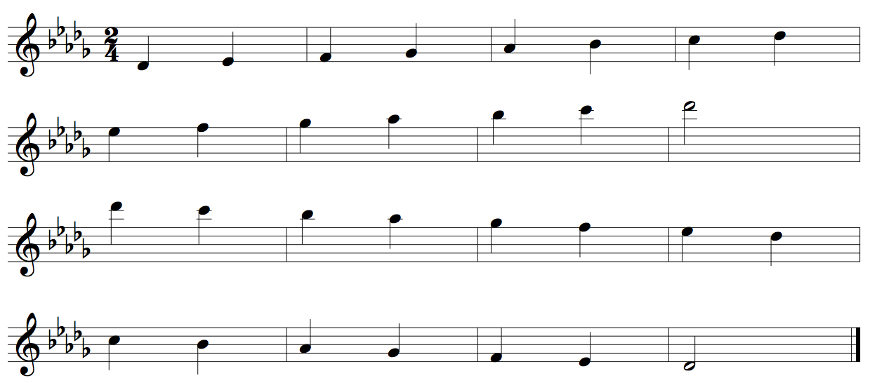
Tenor Saxophone Concert E Scale Two Octaves
Quarter Notes #24
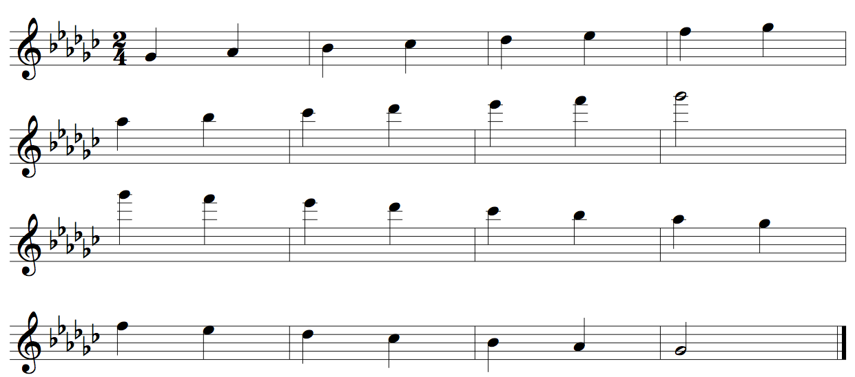

Tenor Saxophone Concert A Scale Two Octaves
Quarter Notes #24
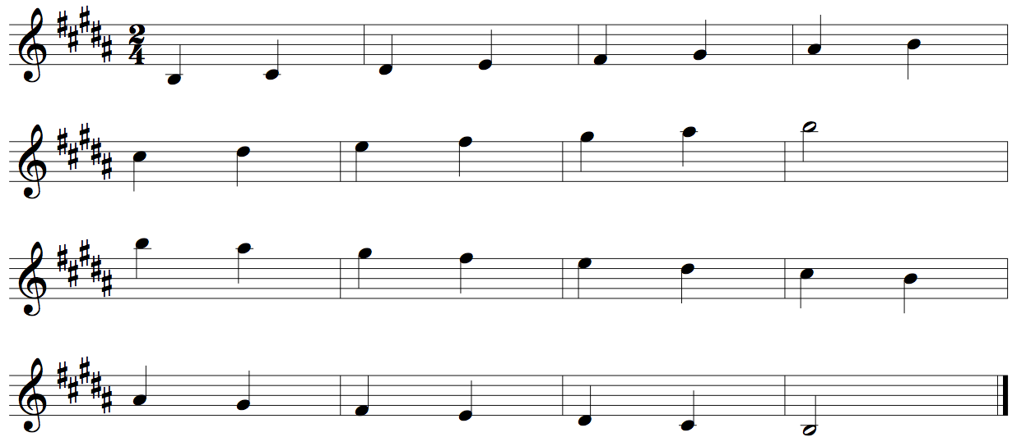
Tenor Saxophone Concert D Scale Two Octaves
Quarter Notes #24
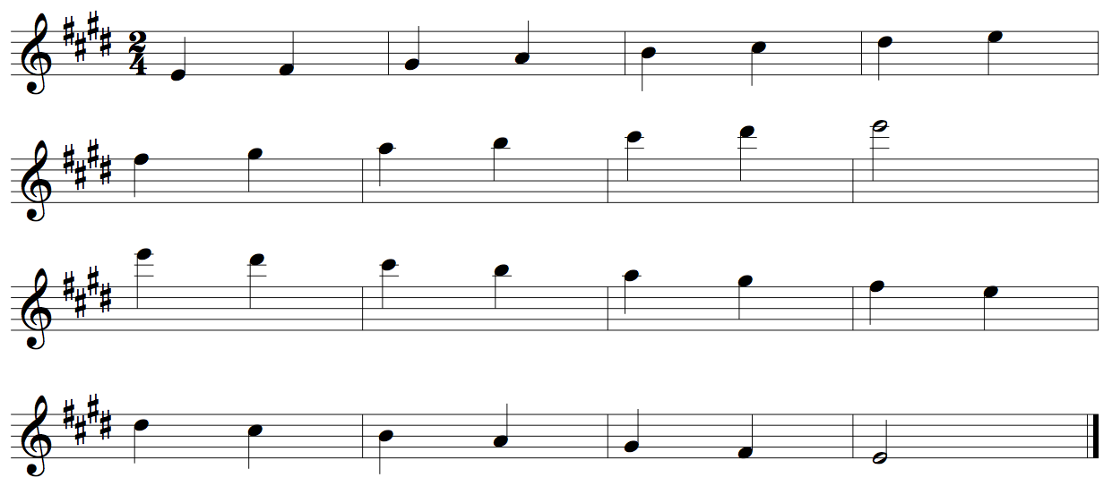
Tenor Saxophone Concert G Scale Two Octaves
Quarter Notes #24
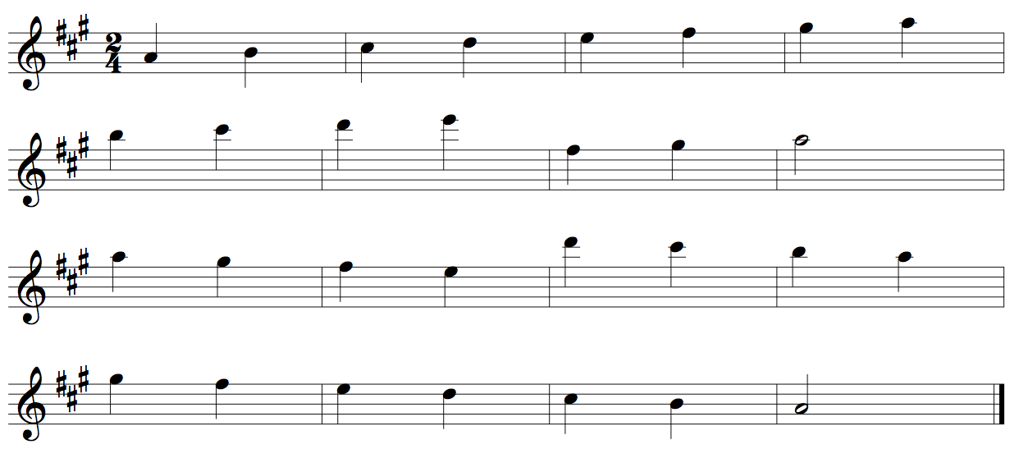
Tenor Saxophone Concert C Scale Two Octaves
Quarter Notes #24
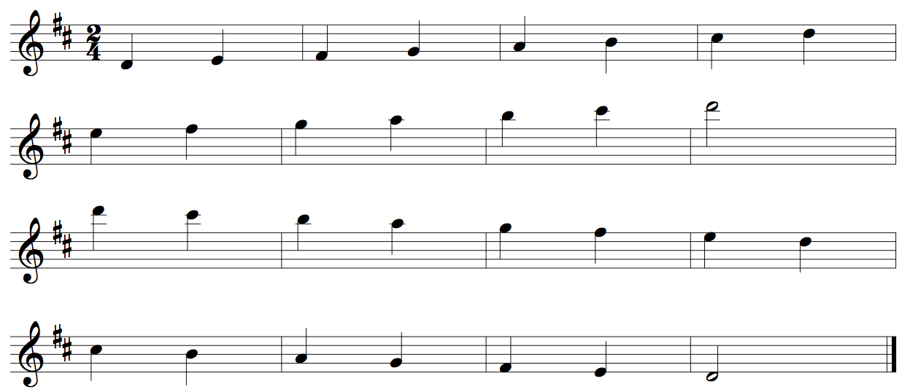
Tenor Saxophone Concert F Scale Two Octaves
Quarter Notes #24
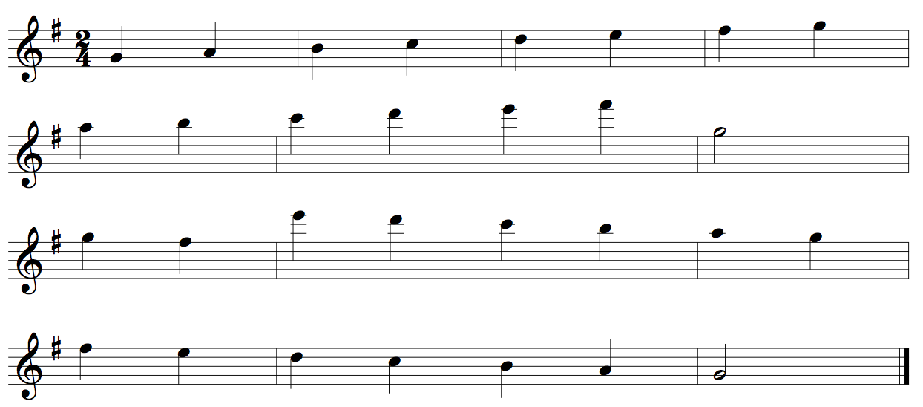

French Horn Concert Bb Chromatic One Octave
Quarter Notes #420
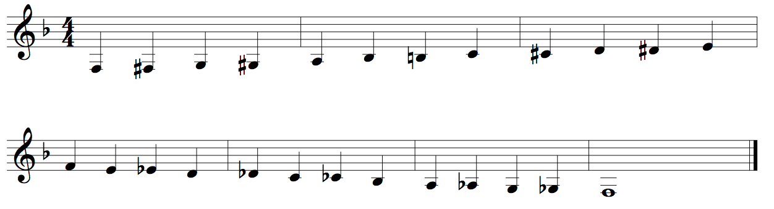
French Horn Concert Bb Chromatic Two Octaves
Quarter Notes #422
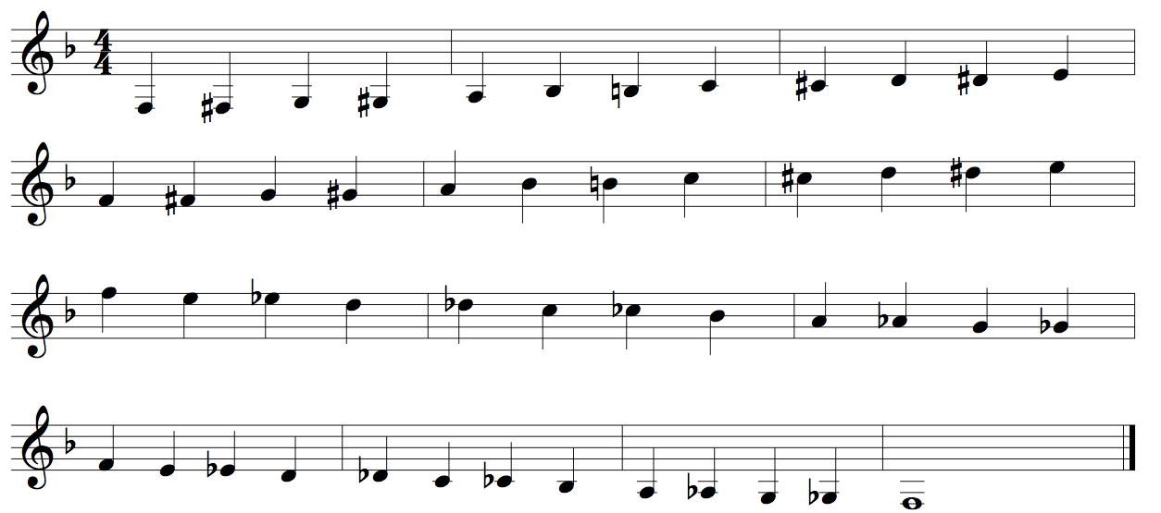

French Horn Concert Bb Scale Two Octaves
Quarter Notes #24

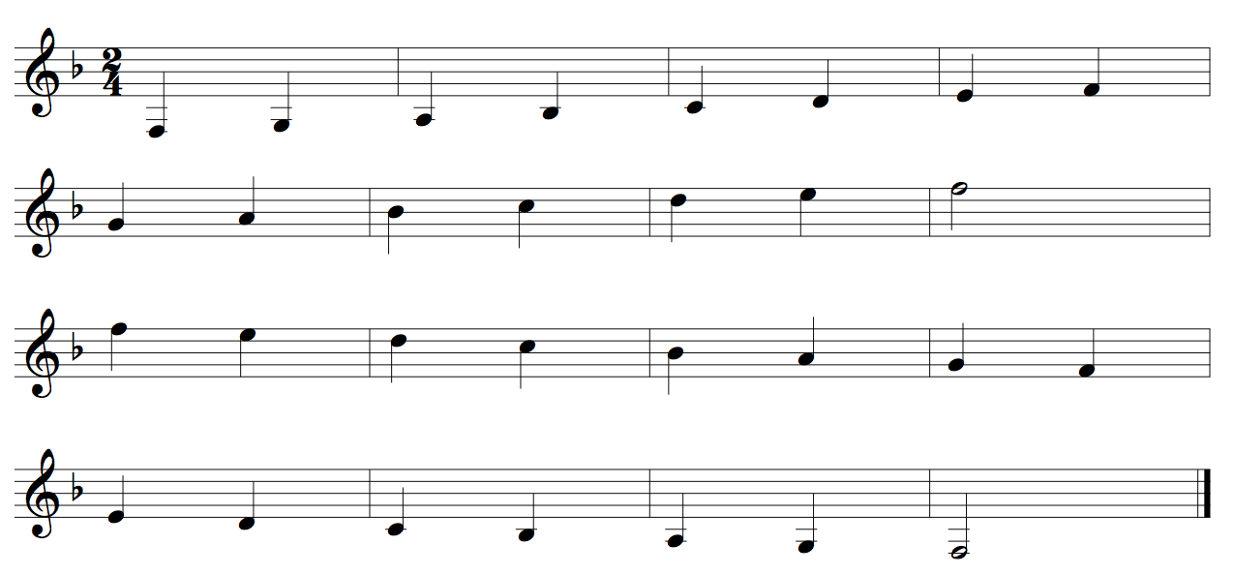

French Horn Concert Eb Scale Two Octaves
Quarter Notes #24

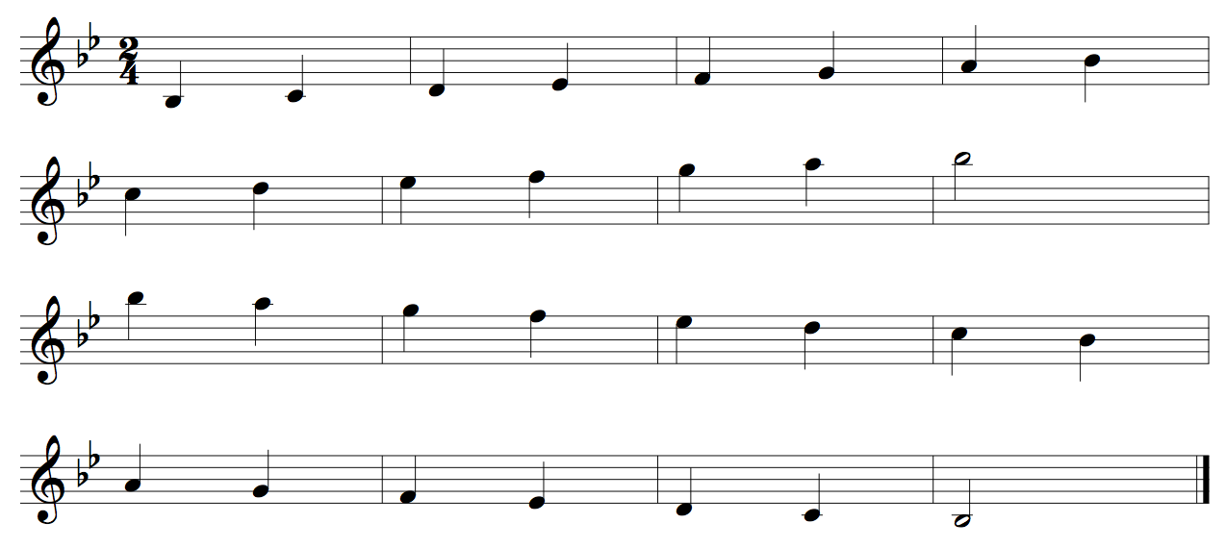

French Horn Concert Ab Scale Two Octaves
Quarter Notes #24

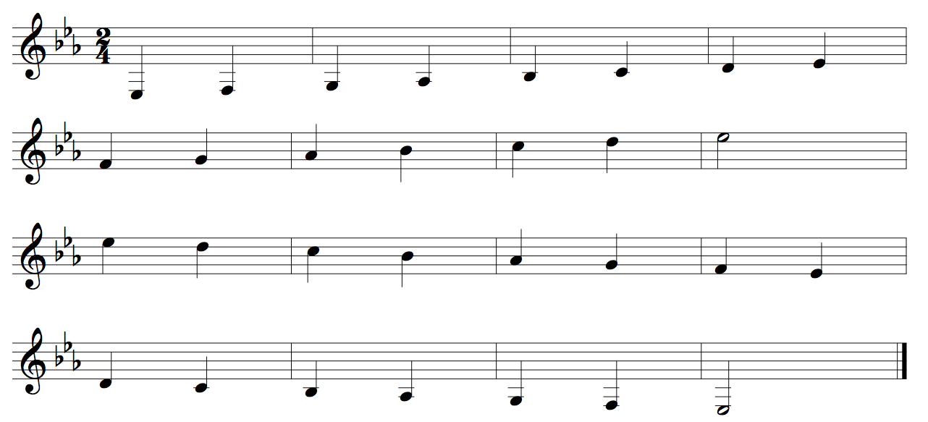

French Horn Concert Db Scale Two Octaves
Quarter Notes #24
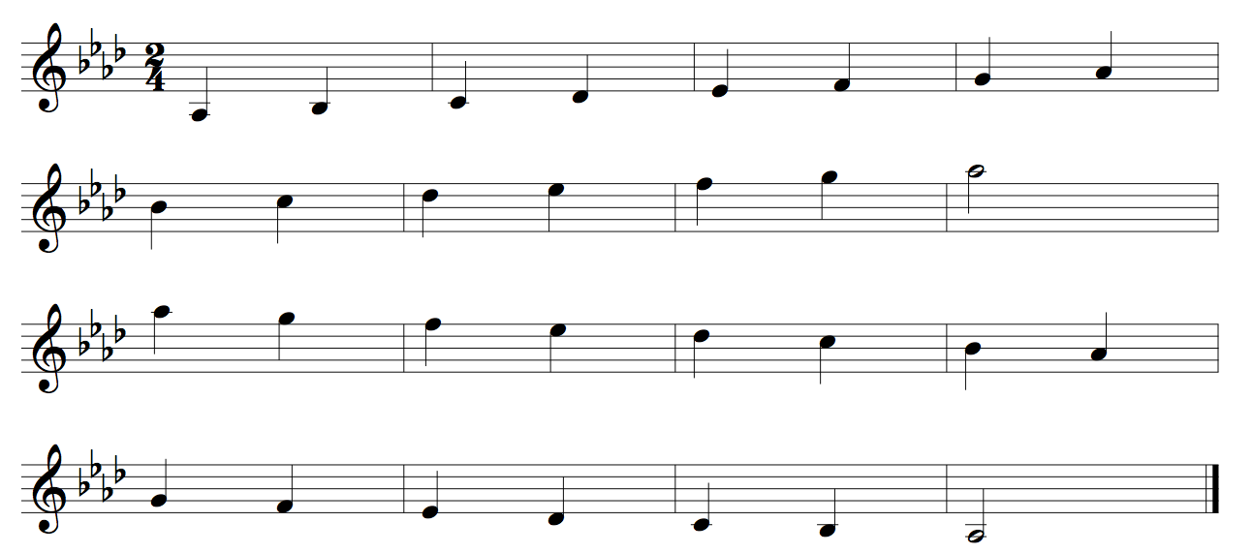

French Horn Concert Gb Scale Two Octaves
Quarter Notes #24
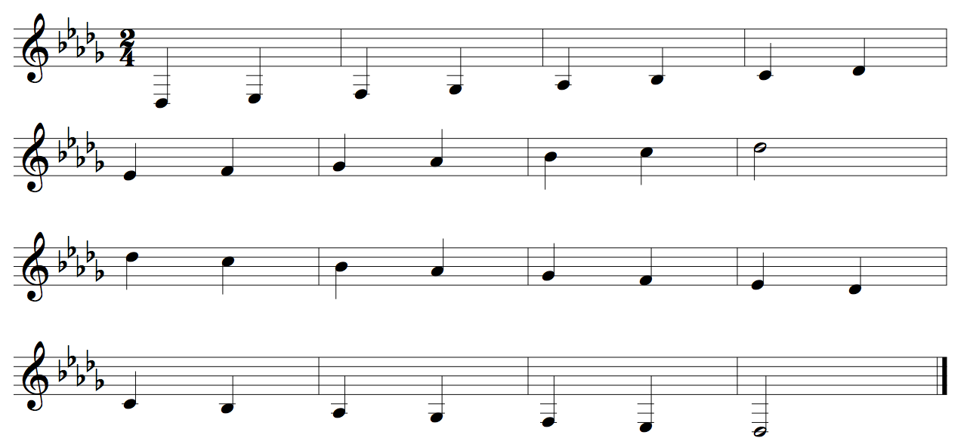

French Horn Concert Cb Scale Two Octaves
Quarter Notes #24
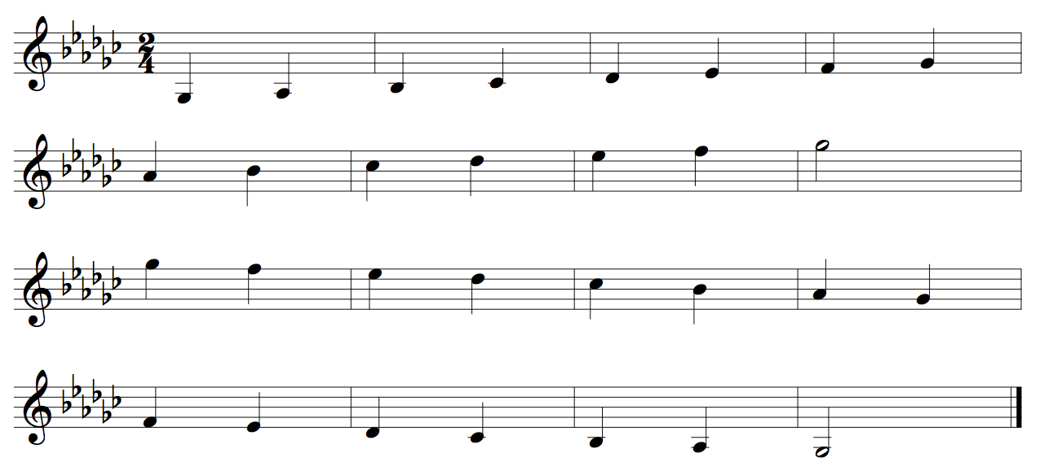

French Horn Concert E Scale Two Octaves
Quarter Notes #24
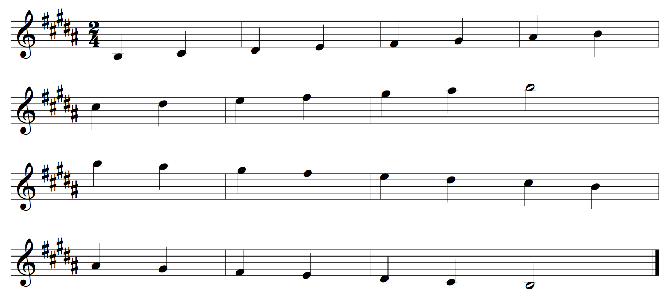

French Horn Concert A Scale Two Octaves
Quarter Notes #24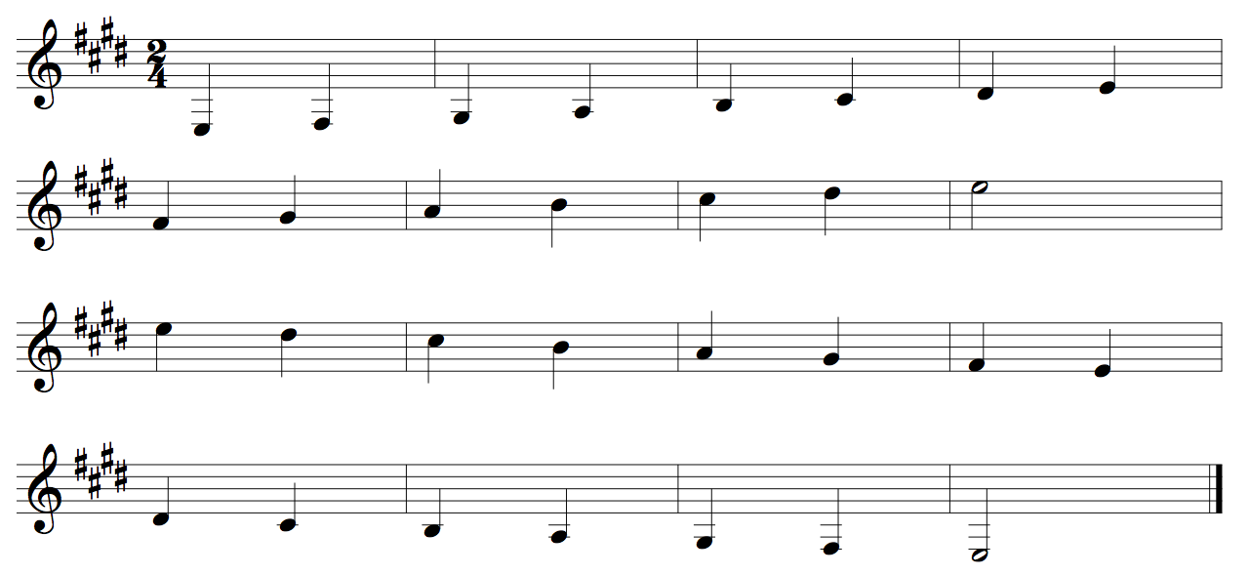

French Horn Concert D Scale Two Octaves
Quarter Notes #24
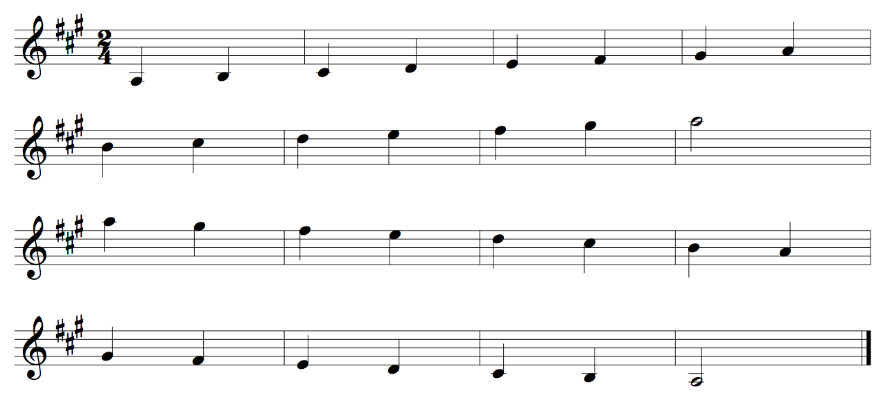

French Horn Concert G Scale Two Octaves
Quarter Notes #24
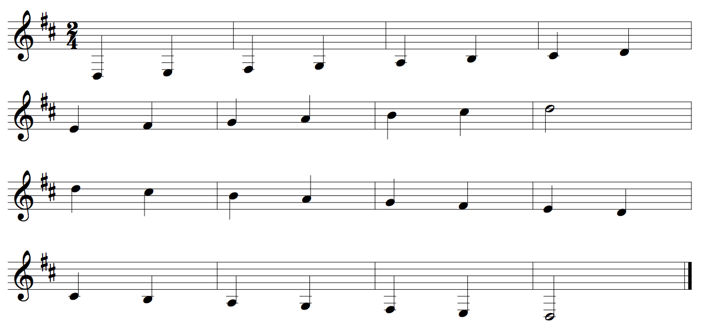
French Horn Concert C Scale Two Octaves
Quarter Notes #24
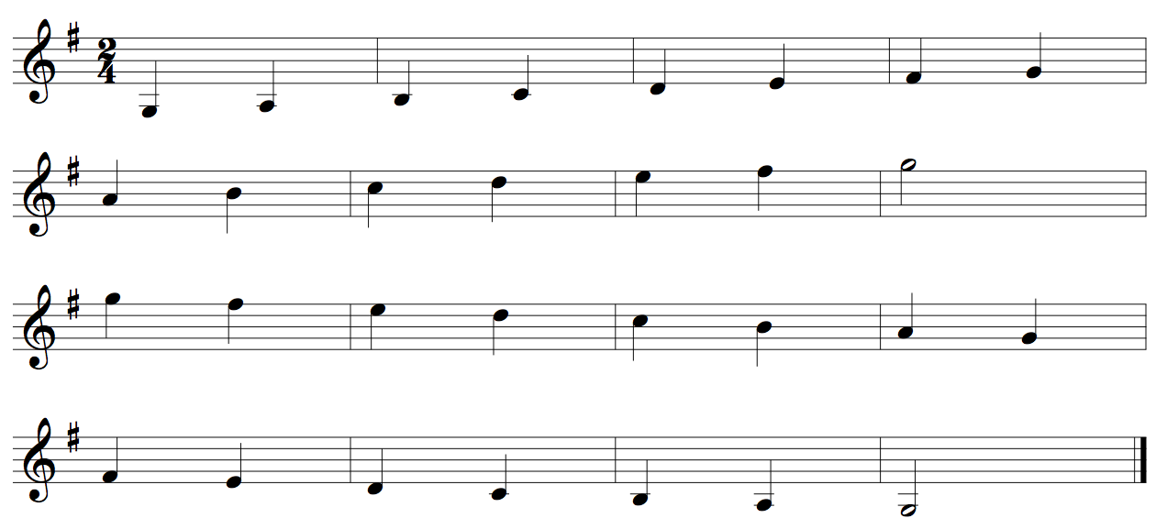

French Horn Concert F Scale Two Octaves
Quarter Notes #24
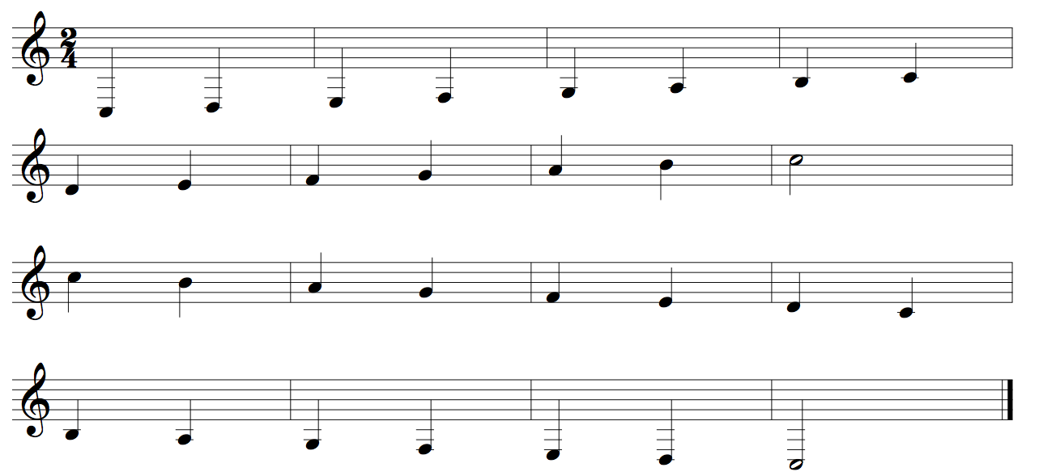

Trumpet Concert Bb Chromatic One Octave
Quarter Notes #420
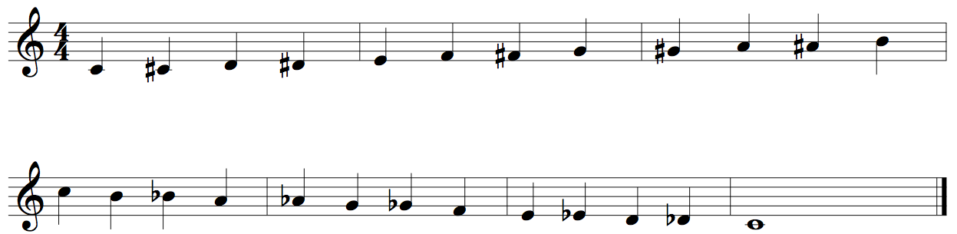
Trumpet Chromatic Two Octaves
Quarter Notes #422
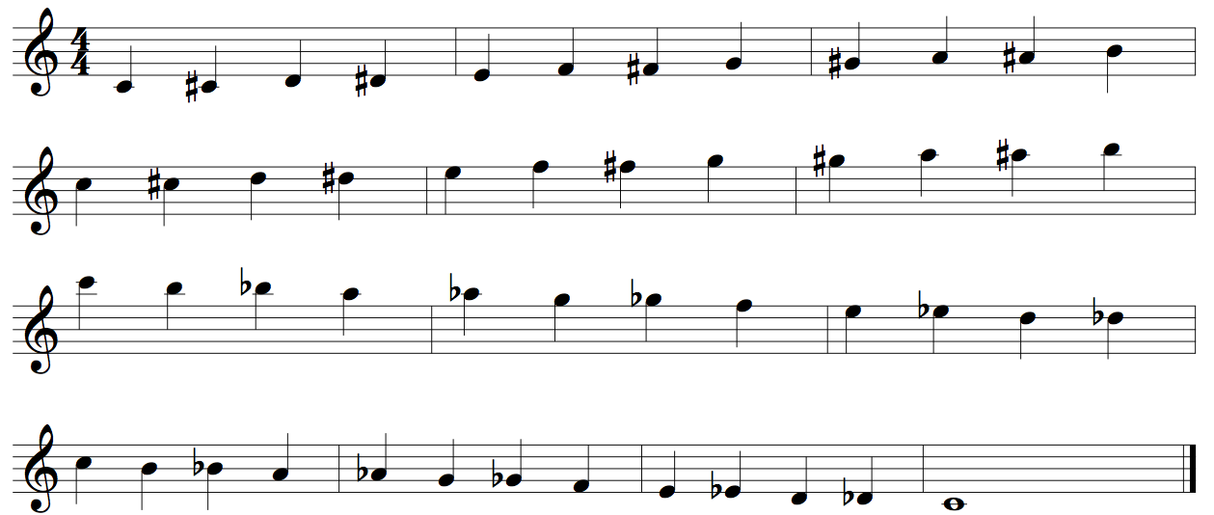

Trumpet Concert Bb Scale Two Octaves
Quarter Notes #24
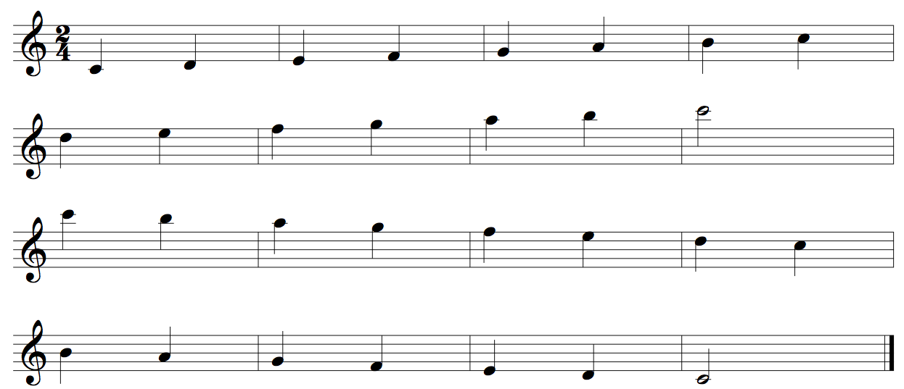

Trumpet Concert Eb Scale Two Octaves
Quarter Notes #24
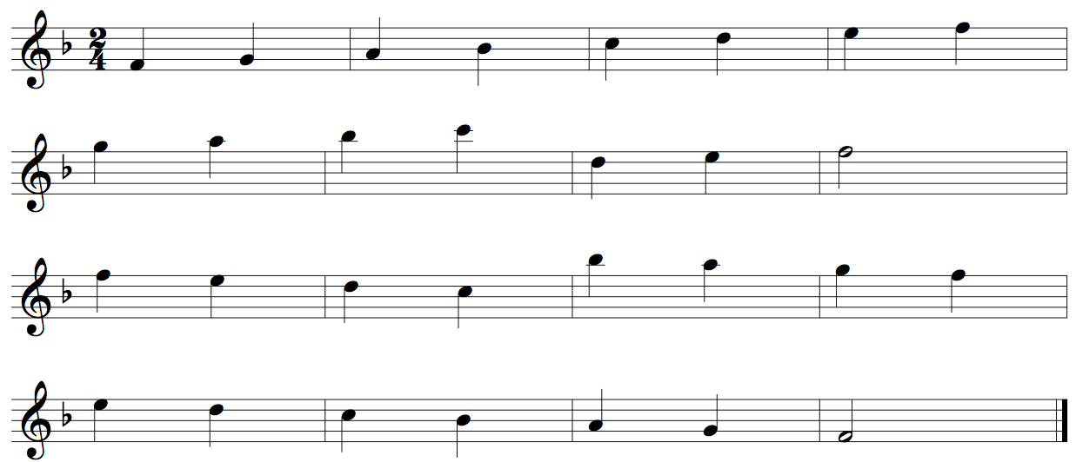
Trumpet Concert Ab Scale Two Octaves
Quarter Notes #24
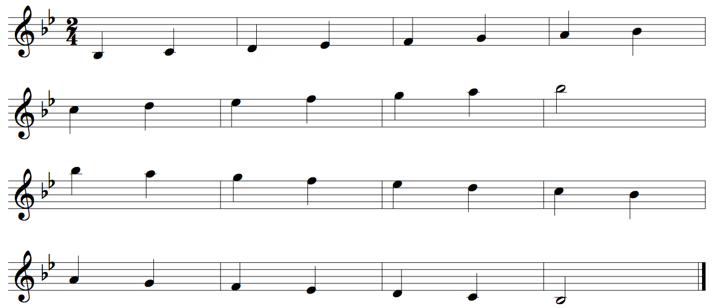
Trumpet Concert Db Scale Two Octaves
Quarter Notes #24
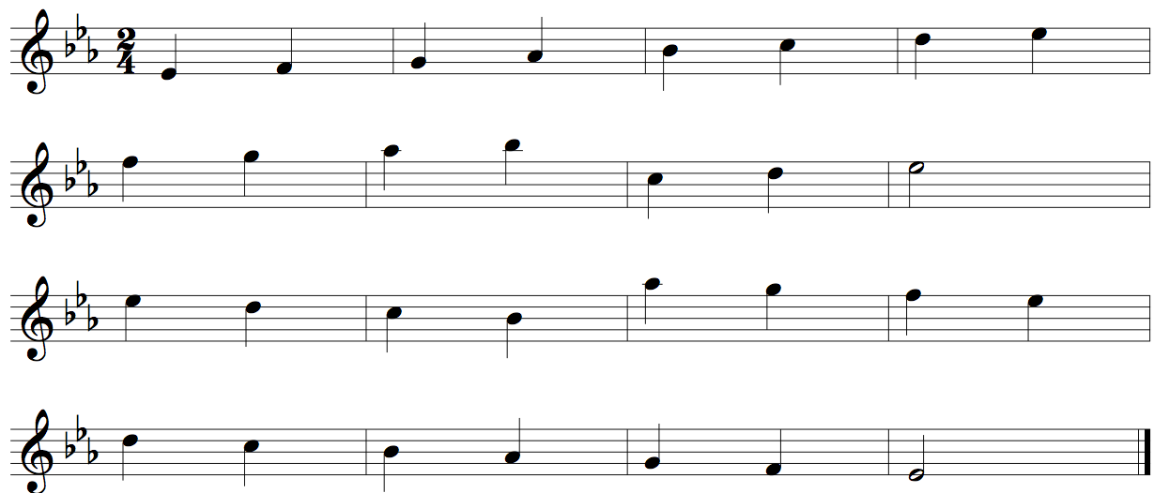

Trumpet Concert Gb Scale Two Octaves
Quarter Notes #24
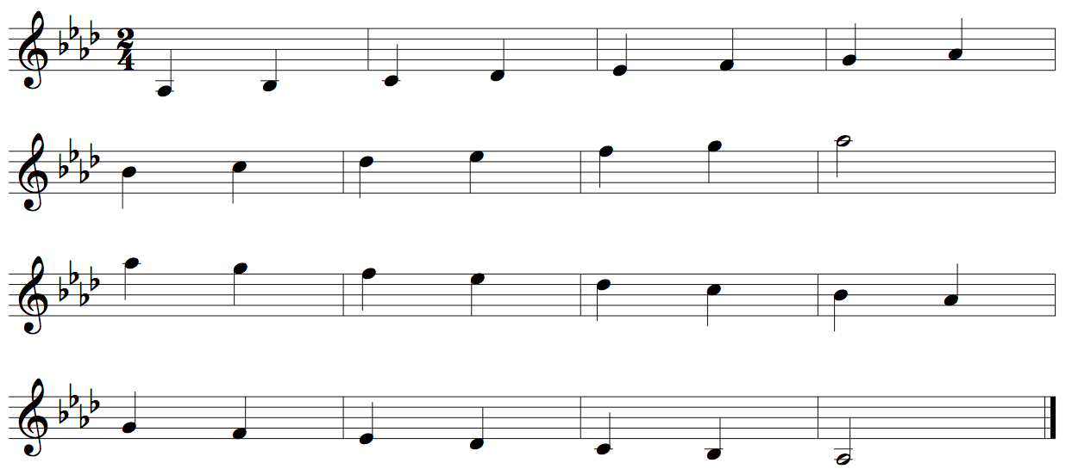

Trumpet Concert Cb Scale Two Octaves
Quarter Notes #24
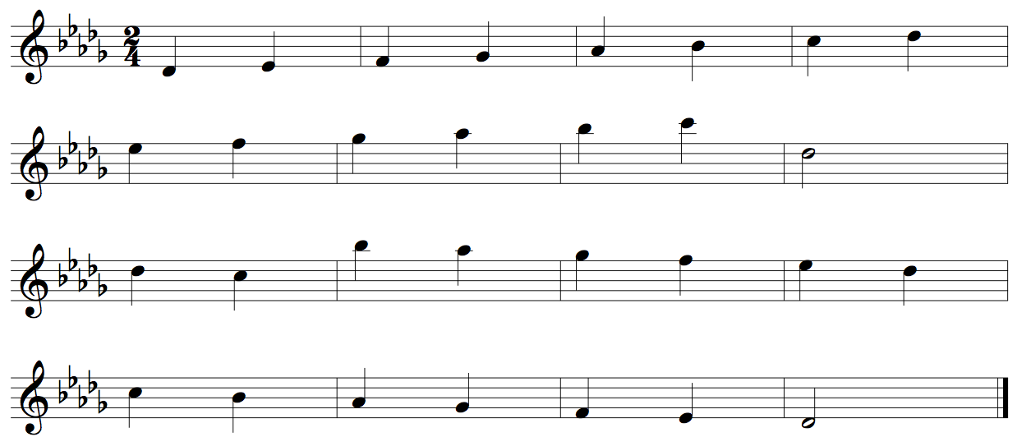
Trumpet Concert E Scale Two Octaves
Quarter Notes #24
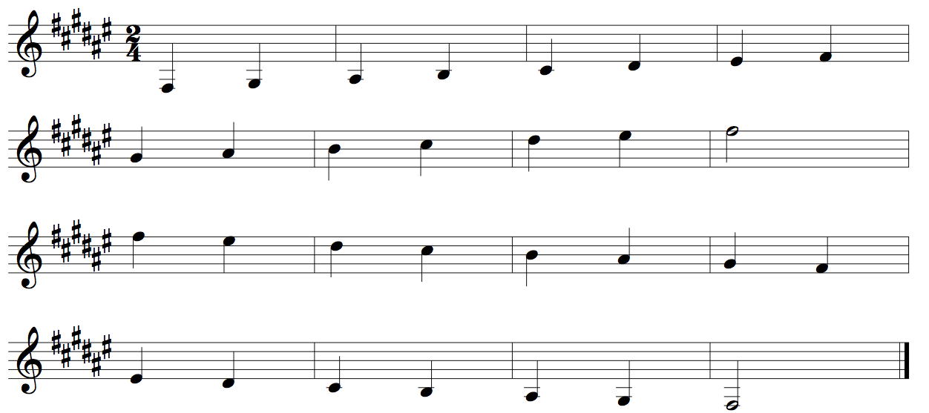
Trumpet Concert A Scale Two Octaves
Quarter Notes #24
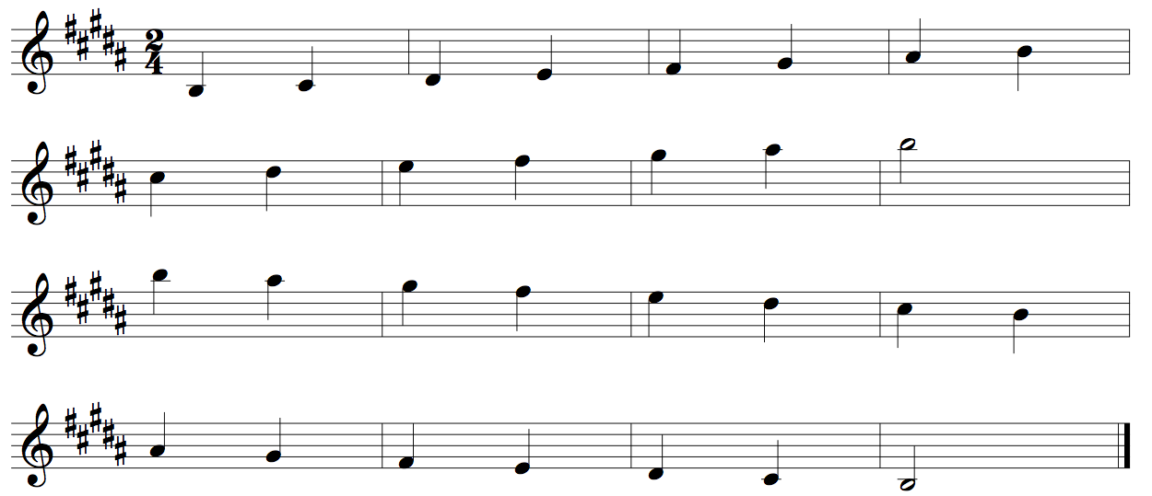

Trumpet Concert D Scale Two Octaves
Quarter Notes #24
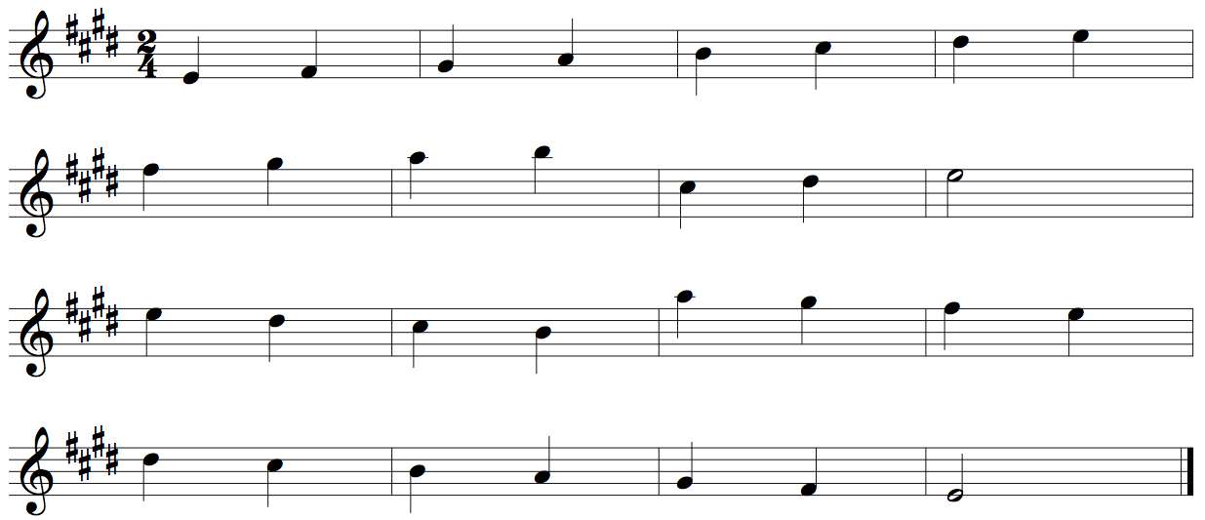
Trumpet Concert G Scale Two Octaves
Quarter Notes #24
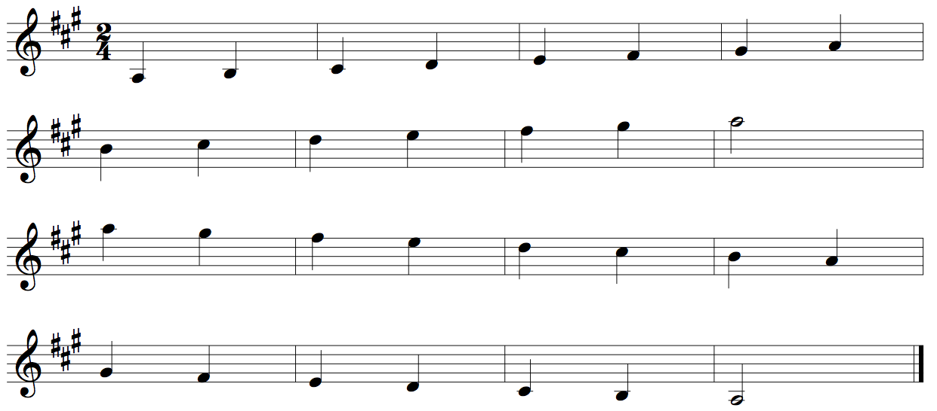
Trumpet Concert C Scale Two Octaves
Quarter Notes #24
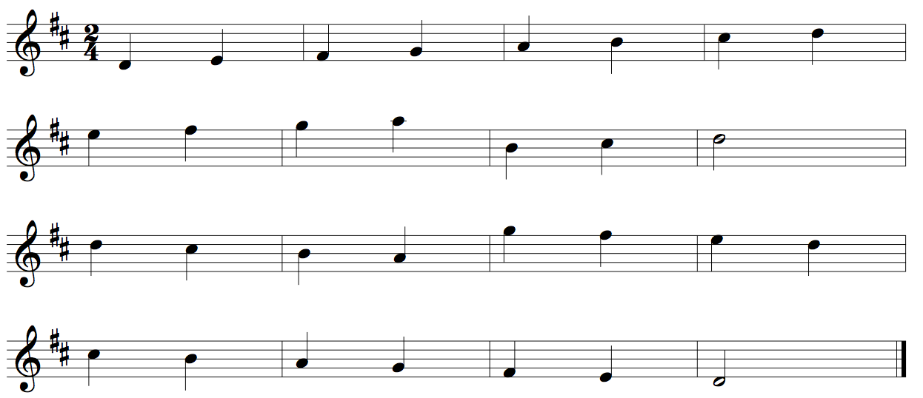
Trumpet Concert F Scale Two Octaves
Quarter Notes #24

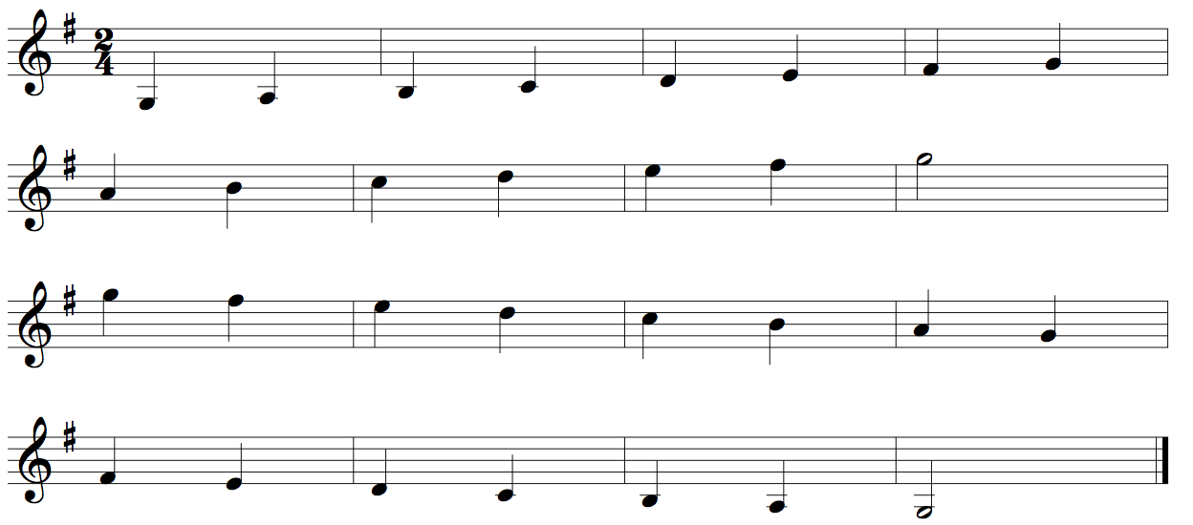

Trombone Concert Bb Chromatic One Octave
Quarter Notes #420
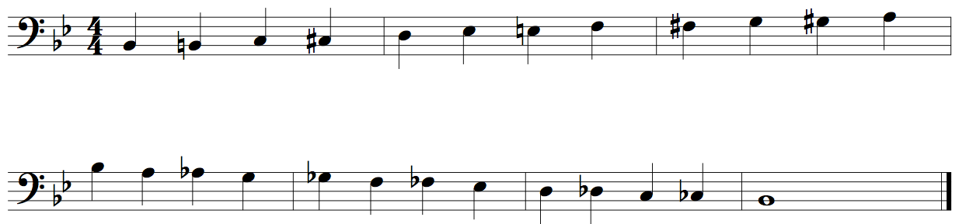
Trombone Chromatic Two Octaves
Quarter Notes #422
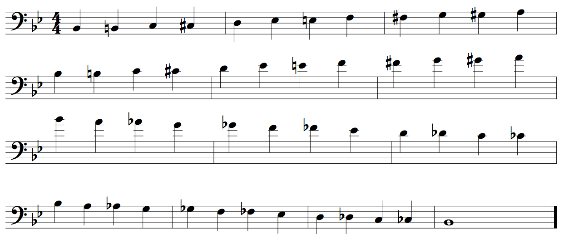
Trombone Concert Bb Scale Two Octaves
Quarter Notes #24
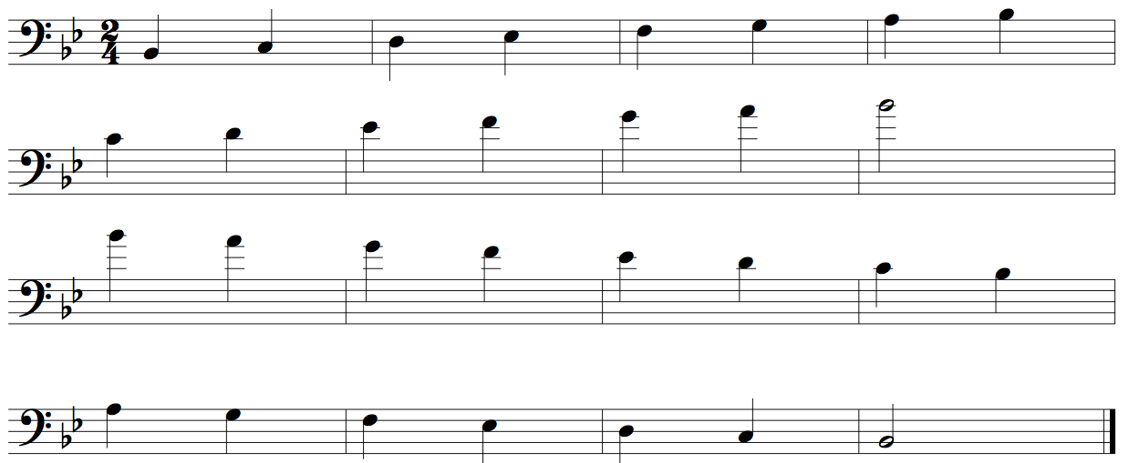

Trombone Concert Eb Scale Two Octaves
Quarter Notes #24
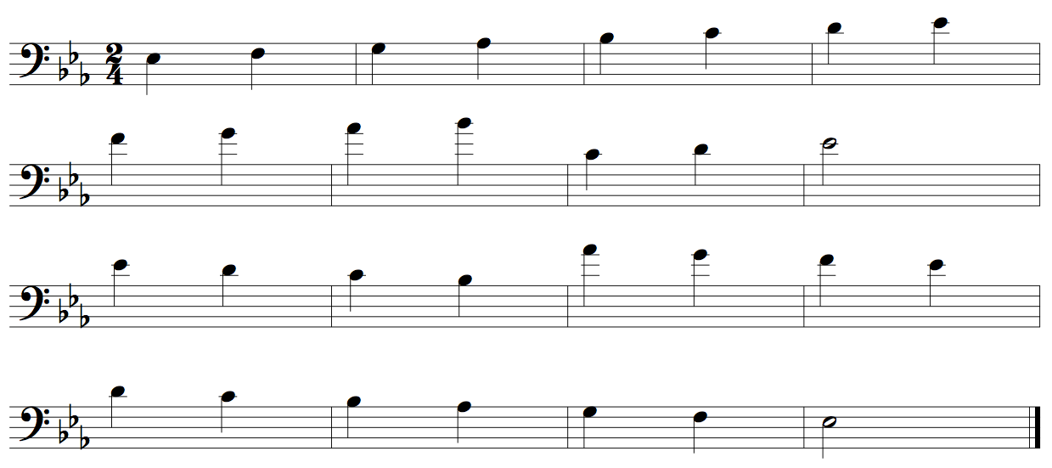
Trombone Concert Ab Scale Two Octaves
Quarter Notes #24
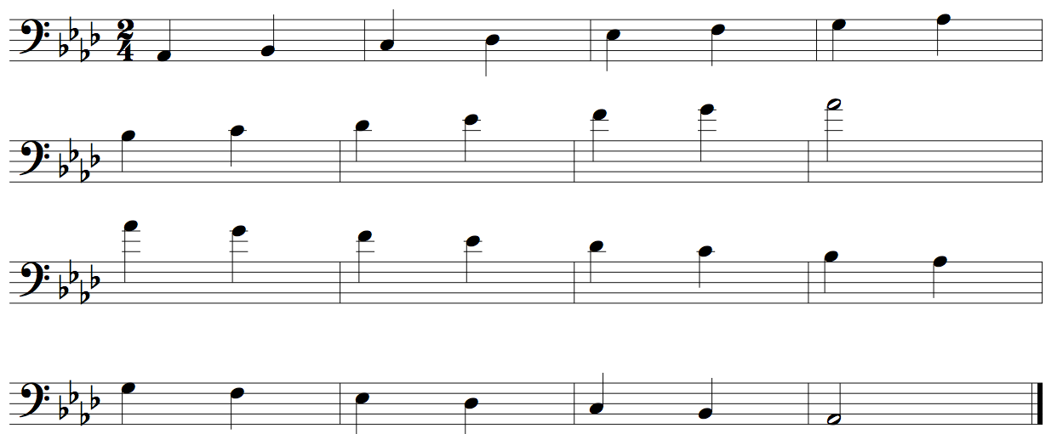
Trombone Concert Db Scale Two Octaves
Quarter Notes #24
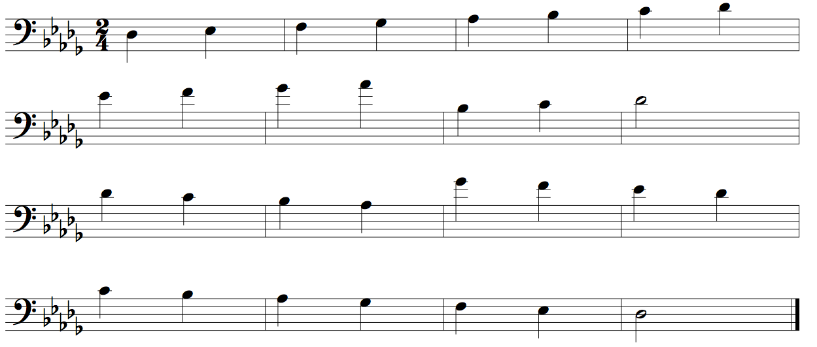

Trombone Concert Gb Scale Two Octaves
Quarter Notes #24
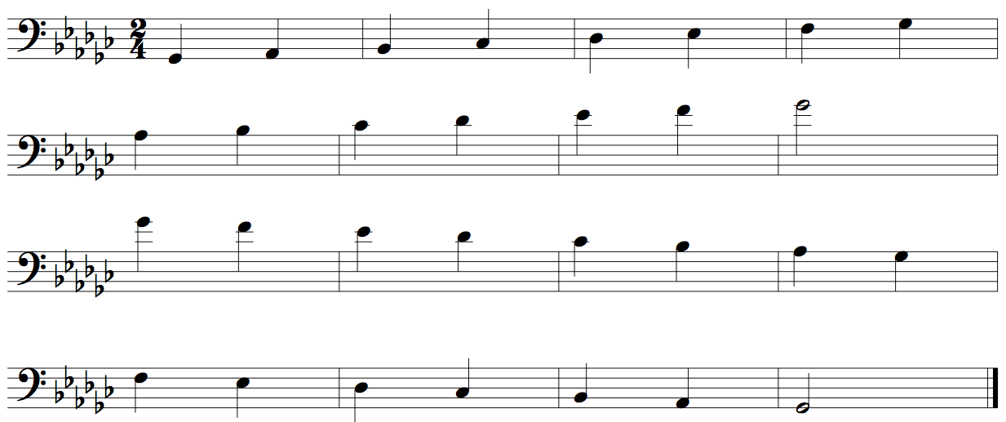
Trombone Concert B Scale Two Octaves
Quarter Notes #24
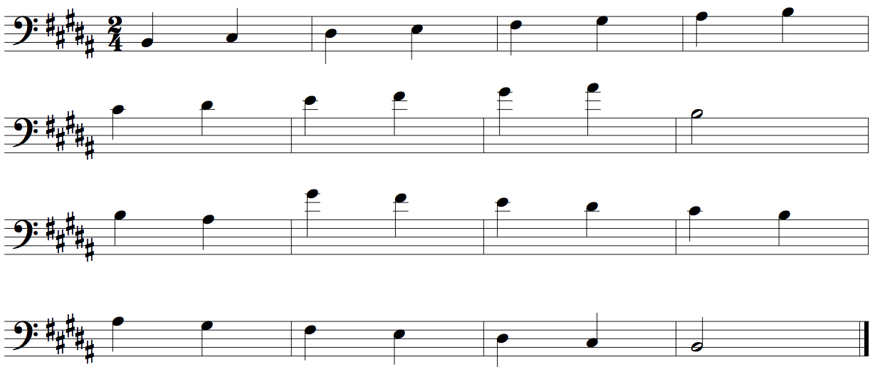
Trombone Concert E Scale Two Octaves
Quarter Notes #24
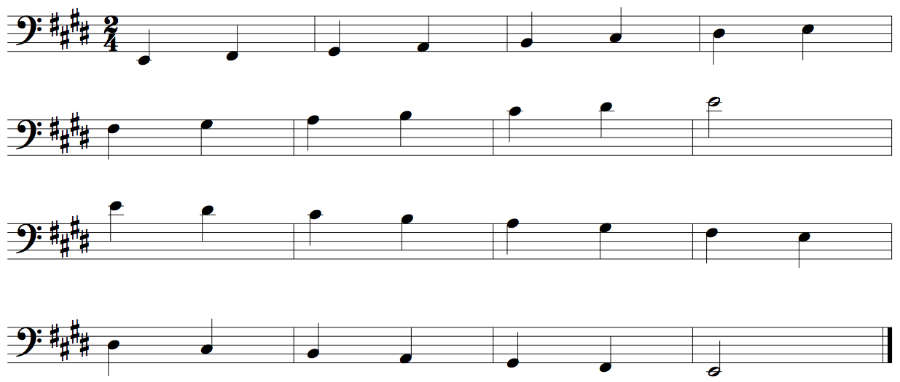

Trombone Concert A Scale Two Octaves
Quarter Notes #24
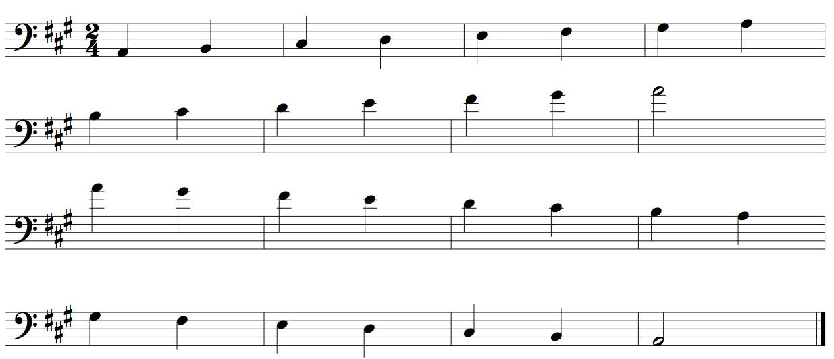
Trombone Concert D Scale Two Octaves
Quarter Notes #24
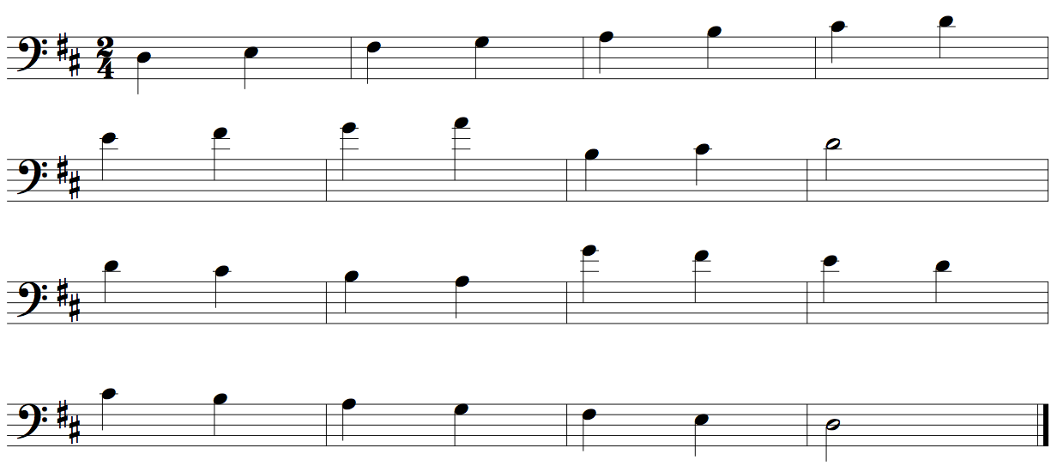
Trombone Concert G Scale Two Octaves
Quarter Notes #24
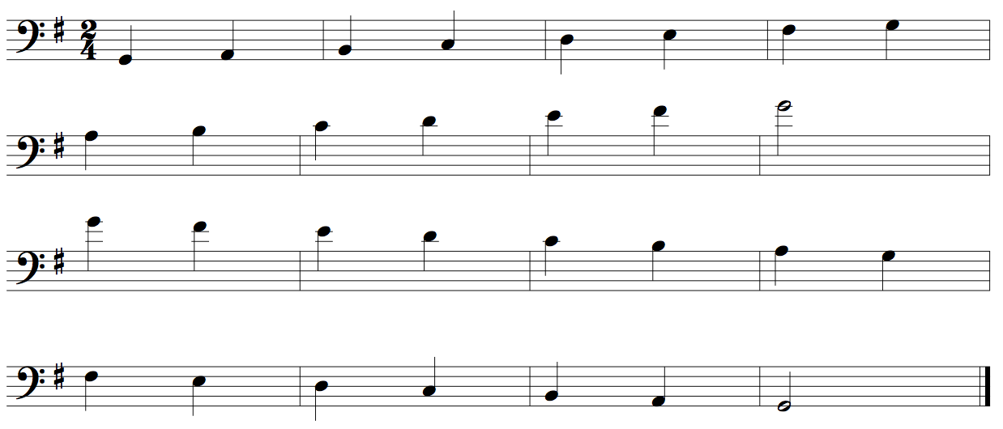

Trombone Concert C Scale Two Octaves
Quarter Notes #24
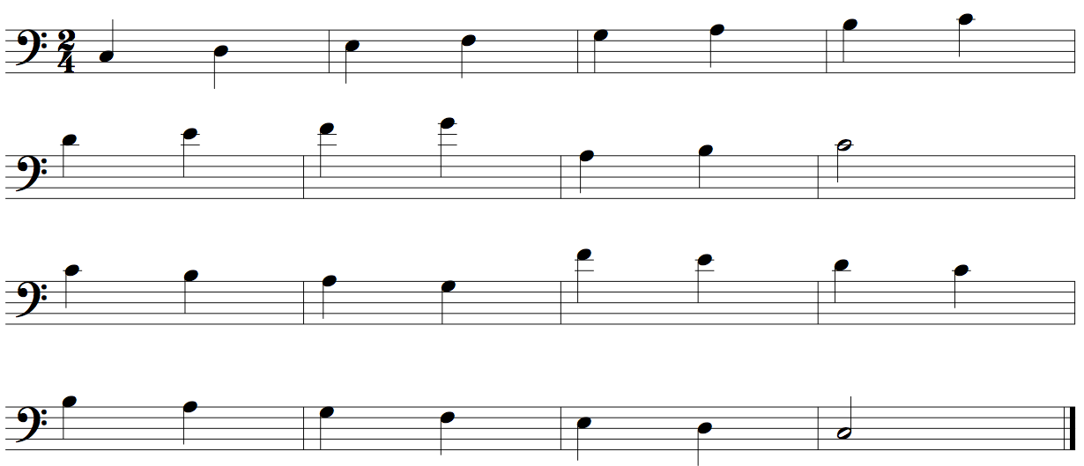
Trombone Concert F Scale Two Octaves
Quarter Notes #24
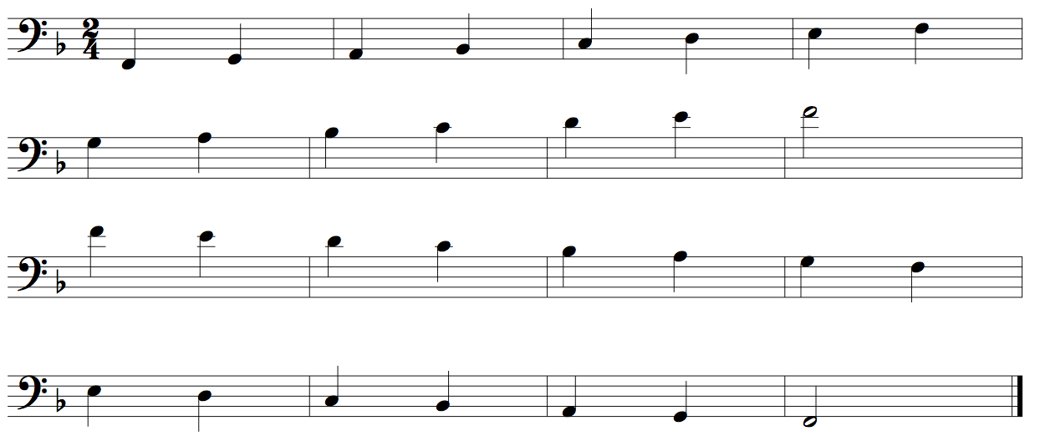

Euphonium Concert Bb Chromatic One Octave
Quarter Notes #420
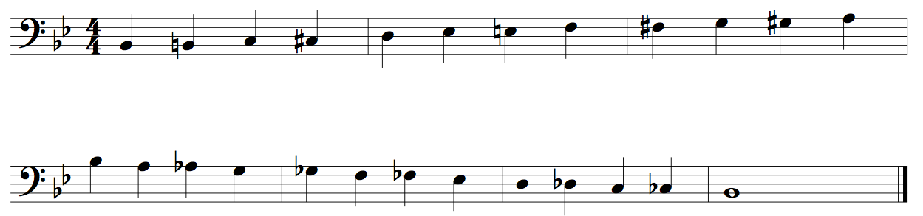
Euphonium Chromatic Two Octaves
Quarter Notes #422

Euphonium Concert Bb Scale Two Octaves
Quarter Notes #24

Euphonium Concert Eb Scale Two Octaves
Quarter Notes #24
Euphonium Concert Ab Scale Two Octaves
Quarter Notes #24
Euphonium Concert Db Scale Two Octaves
Quarter Notes #24

Euphonium Concert Gb Scale Two Octaves
Quarter Notes #24
Euphonium Concert B Scale Two Octaves
Quarter Notes #24

Euphonium Concert E Scale Two Octaves
Quarter Notes #24

Euphonium Concert A Scale Two Octaves
Quarter Notes #24
Euphonium Concert D Scale Two Octaves
Quarter Notes #24
Euphonium Concert G Scale Two Octaves
Quarter Notes #24

Euphonium Concert C Scale Two Octaves
Quarter Notes #24
Euphonium Concert F Scale Two Octaves
Quarter Notes #24

TubaConcert Bb Chromatic One Octave
Quarter Notes #420
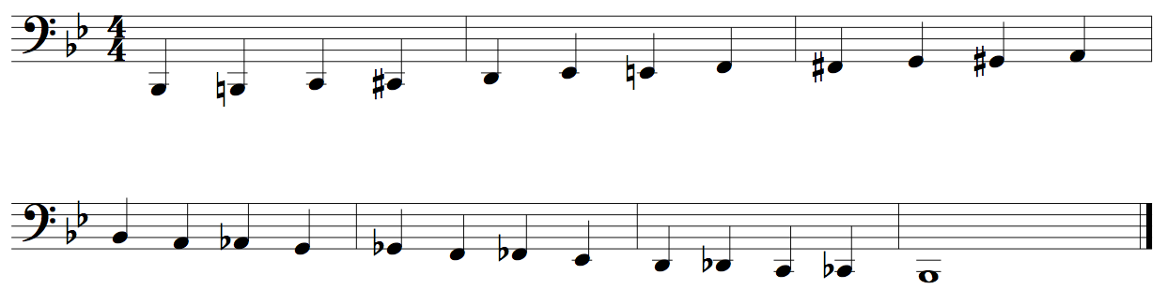
Euphonium Chromatic Two Octaves
Quarter Notes #422
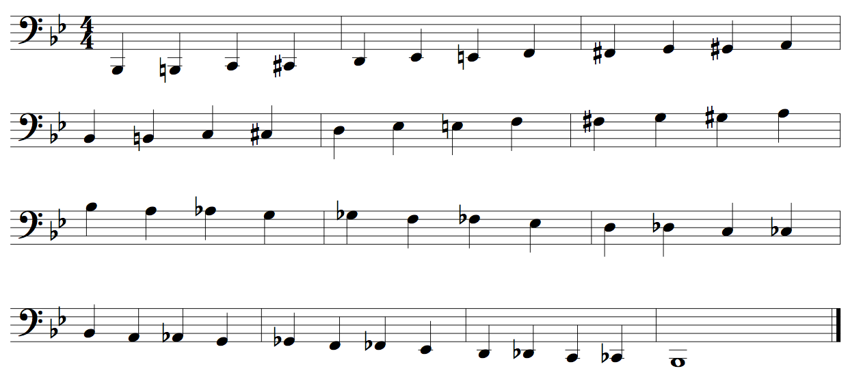

Tuba Concert Bb Scale Two Octaves
Quarter Notes #24
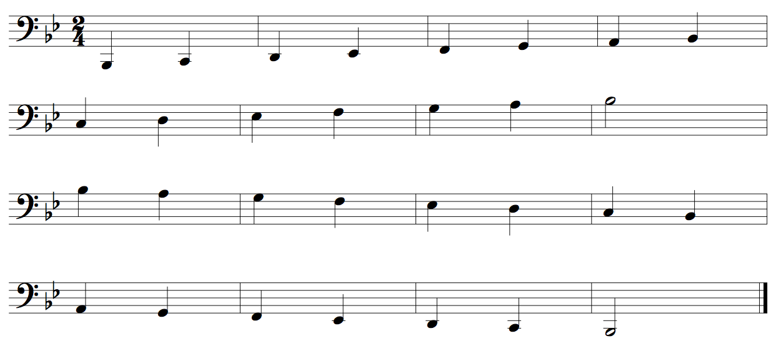

Tuba Concert Eb Scale Two Octaves
Quarter Notes #24
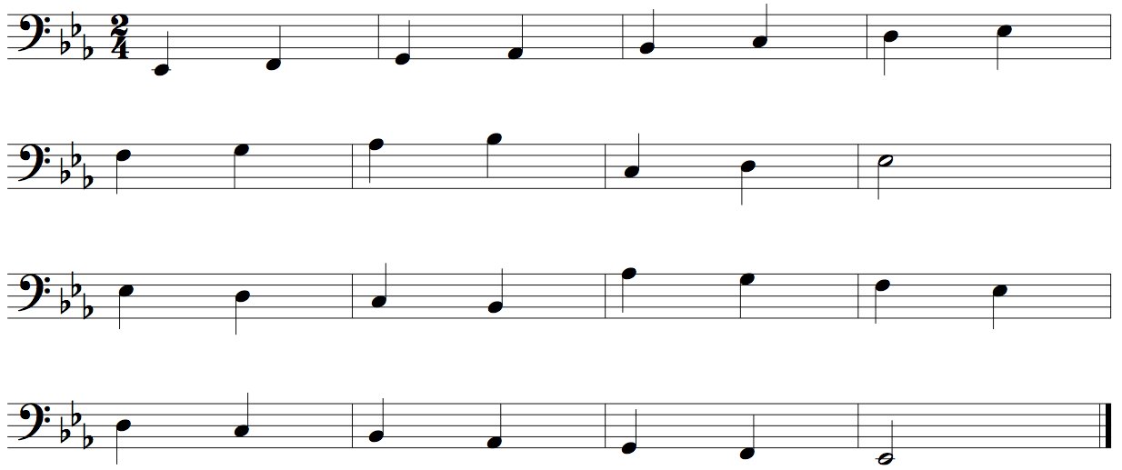
Tuba Concert Ab Scale Two Octaves
Quarter Notes #24
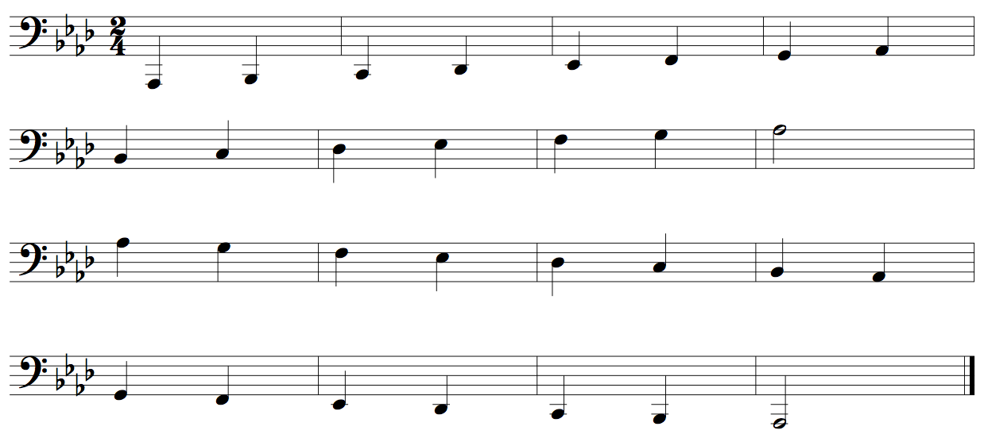
Tuba Concert Db Scale Two Octaves
Quarter Notes #24
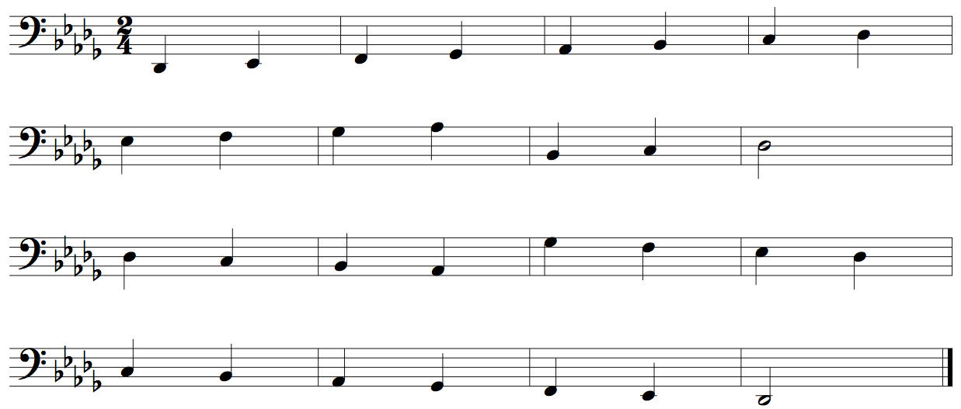

Tuba Concert Gb Scale Two Octaves
Quarter Notes #24
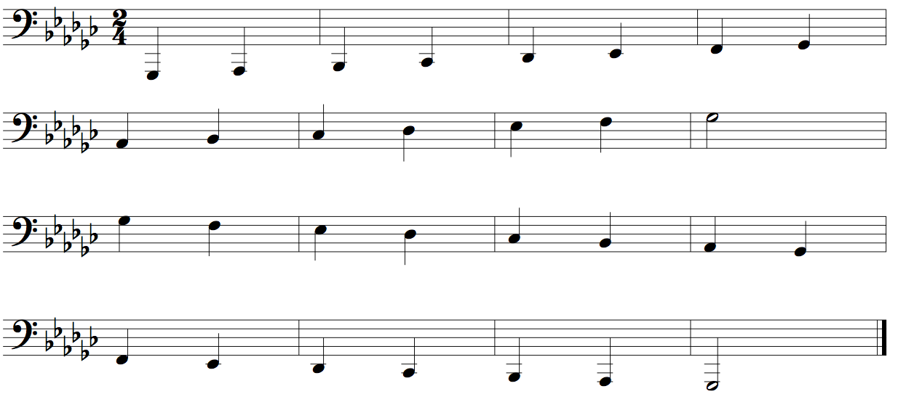
Tuba Concert B Scale Two Octaves
Quarter Notes #24
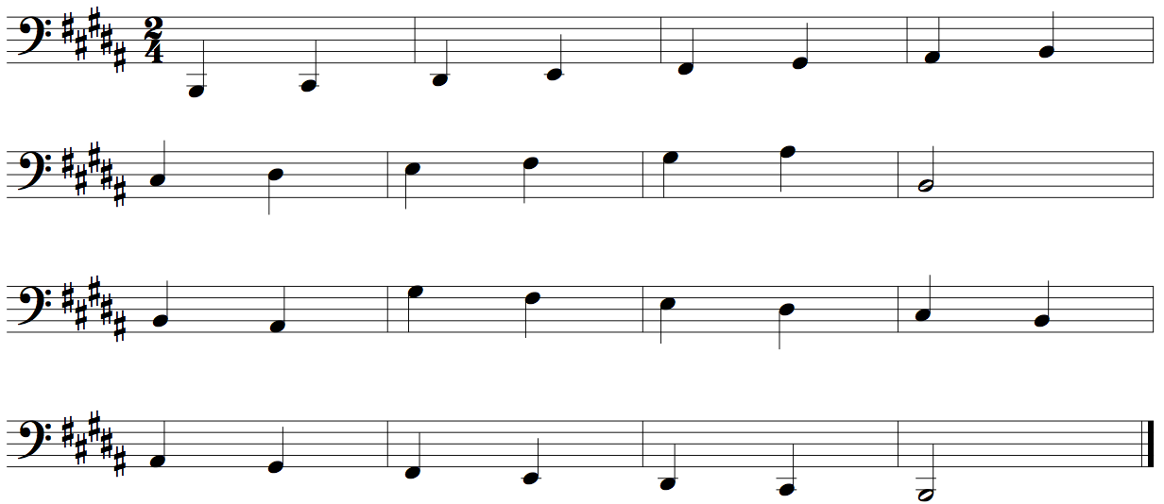
Tuba Concert E Scale Two Octaves
Quarter Notes #24
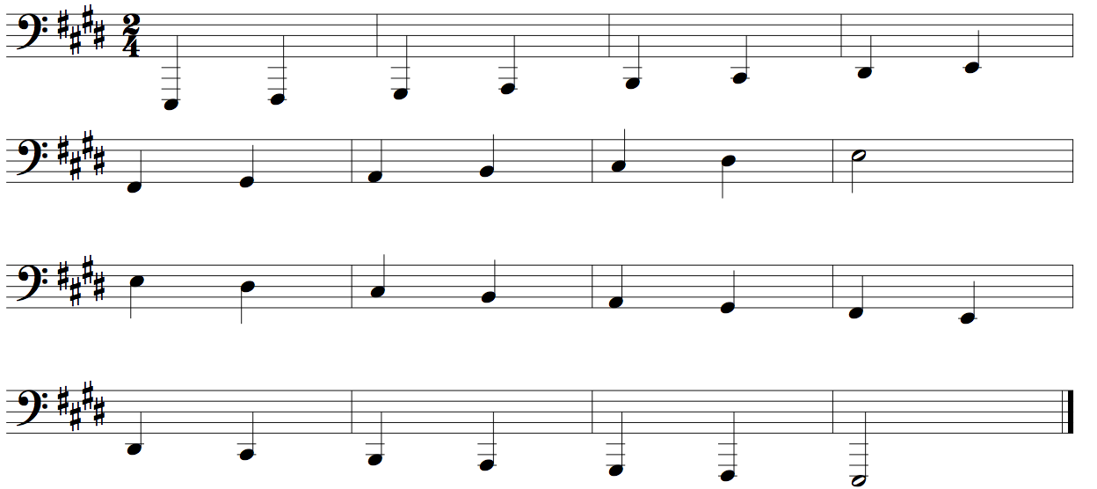
Tuba Concert A Scale Two Octaves
Quarter Notes #24
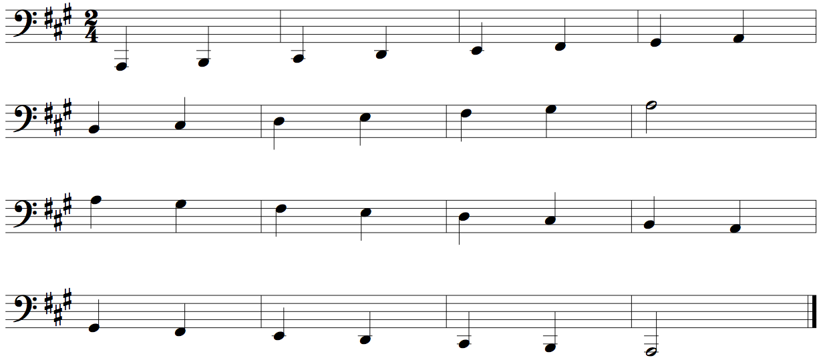
Tuba Concert D Scale Two Octaves
Quarter Notes #24
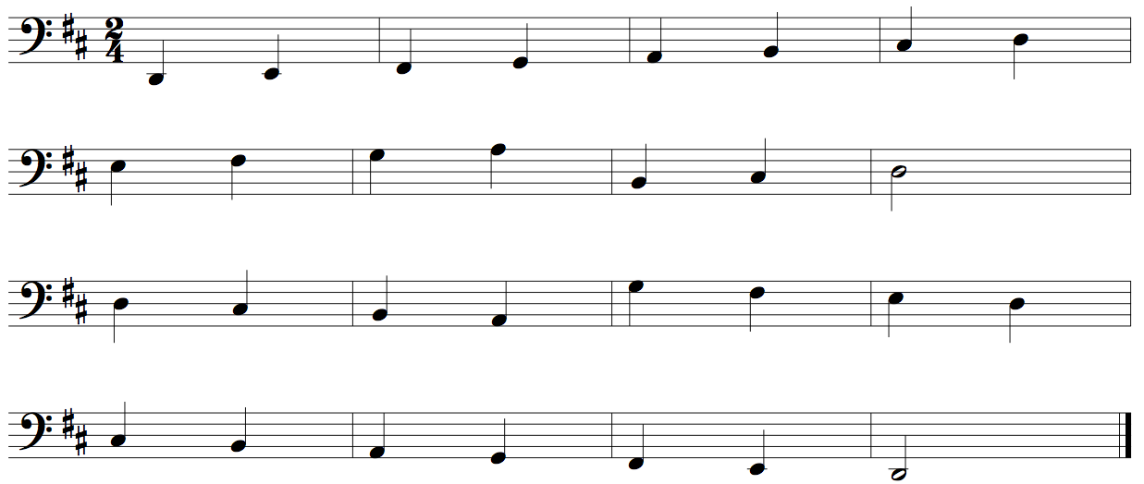

Tuba Concert G Scale Two Octaves
Quarter Notes #24
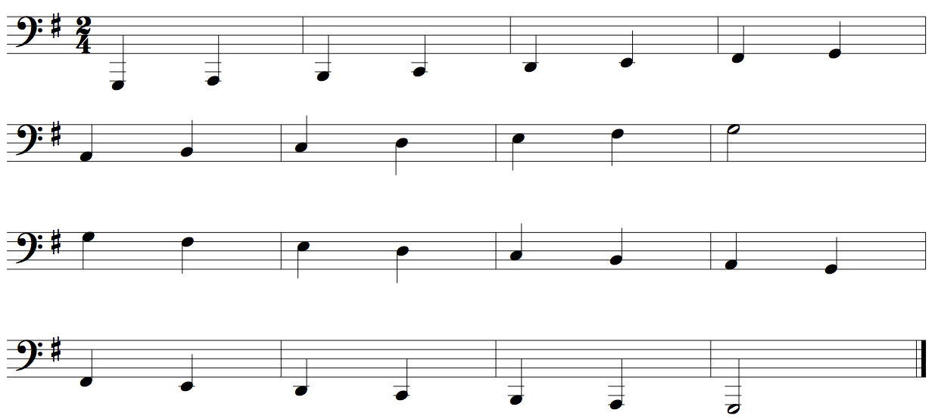
Tuba Concert C Scale Two Octaves
Quarter Notes #24
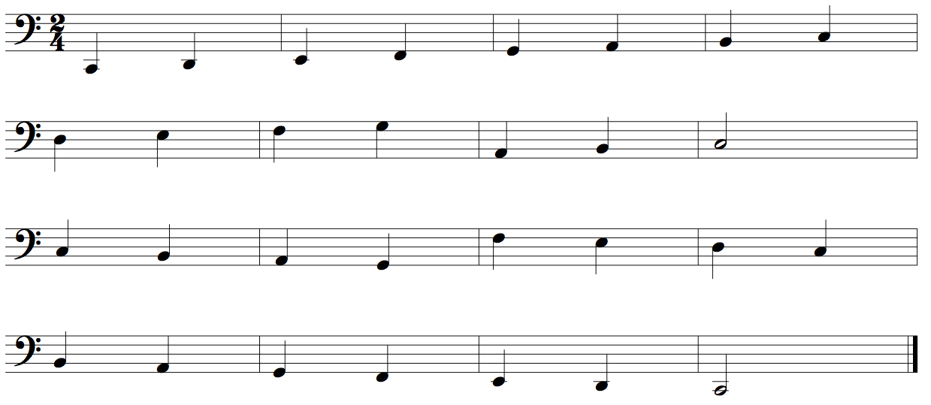
Tuba Concert F Scale Two Octaves
Quarter Notes #24
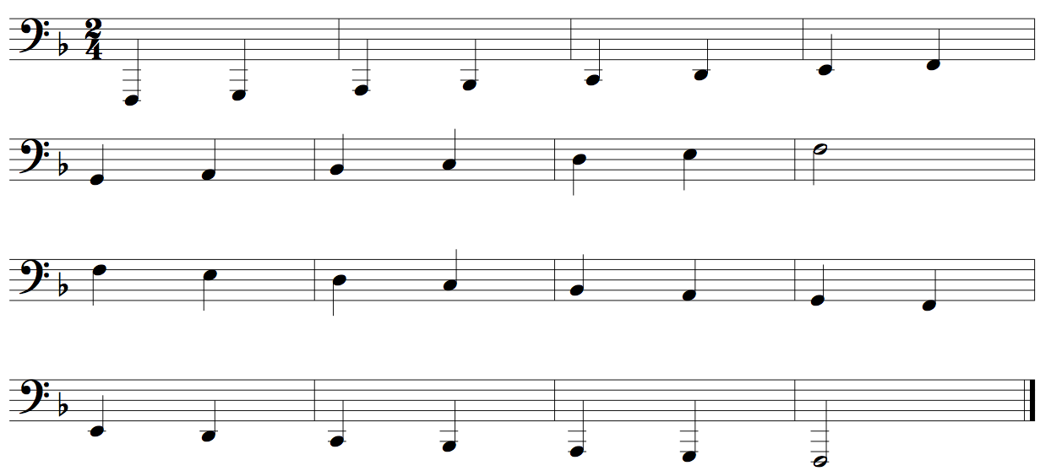

Xylophone Concert Bb Chromatic One Octave
Quarter Notes #420
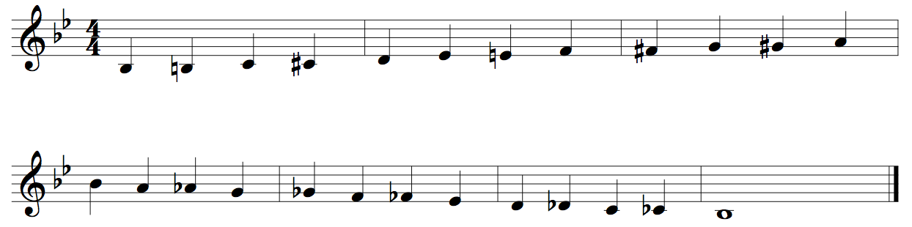
Xylophone Chromatic Two Octaves
Quarter Notes #422
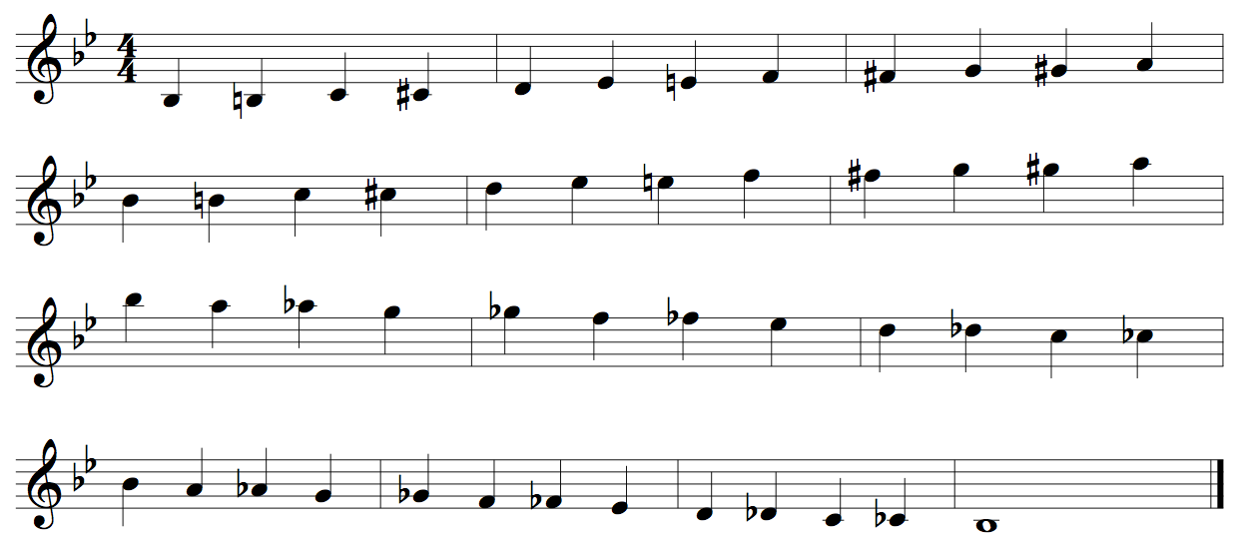
Xylophone Concert Bb Scale Two Octaves
Quarter Notes #24
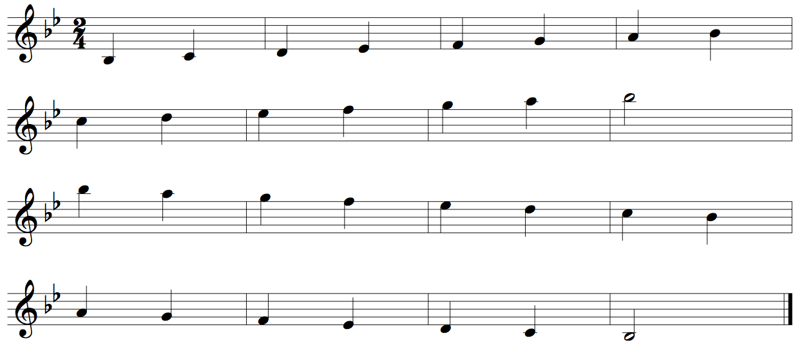

Xylophone Concert Eb Scale Two Octaves
Quarter Notes #24
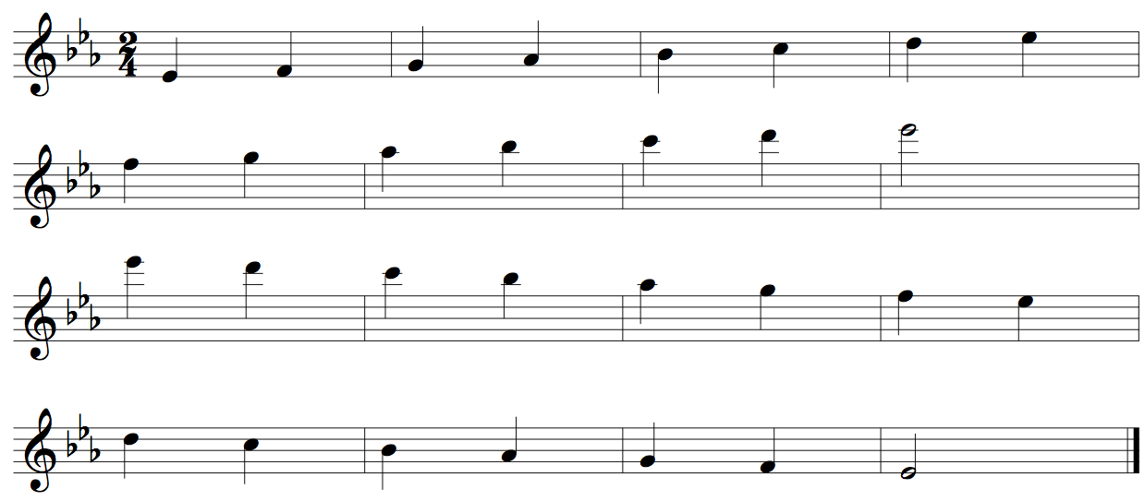
Xylophone Concert Ab Scale Two Octaves
Quarter Notes #24
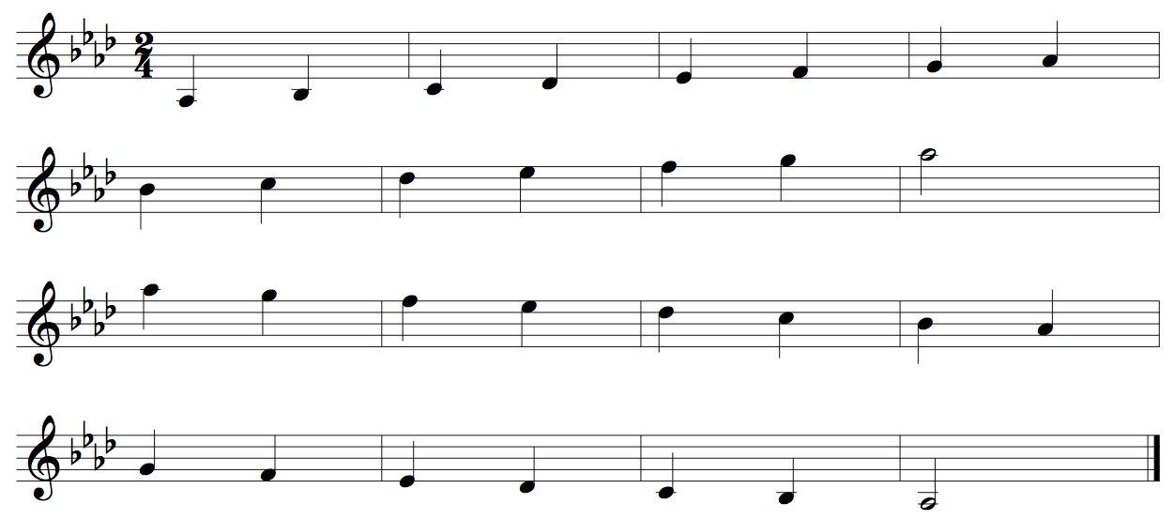
Xylophone Concert Db Scale Two Octaves
Quarter Notes #24
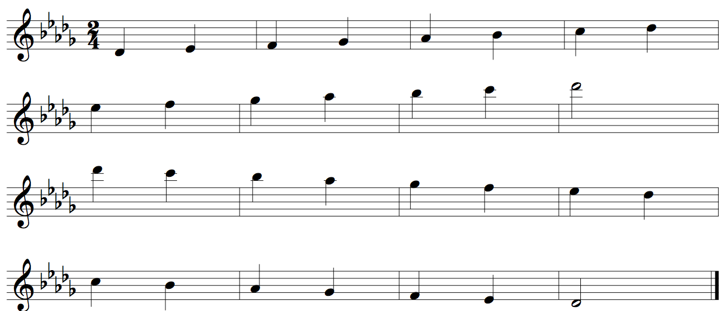

Xylophone Concert Gb Scale Two Octaves
Quarter Notes #24
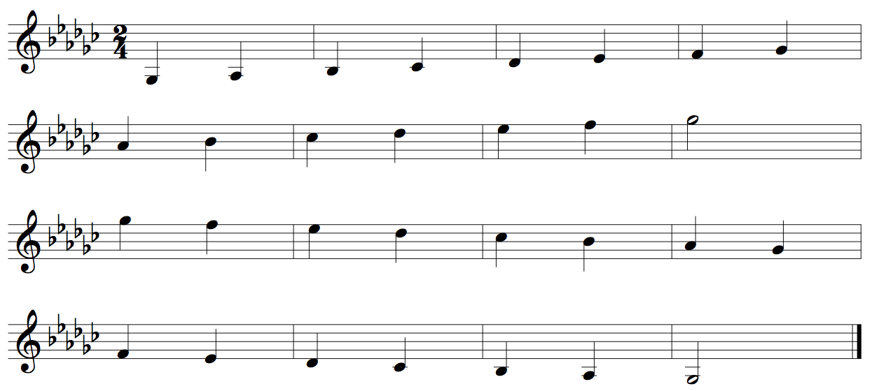
Xylophone Concert B Scale Two Octaves
Quarter Notes #24
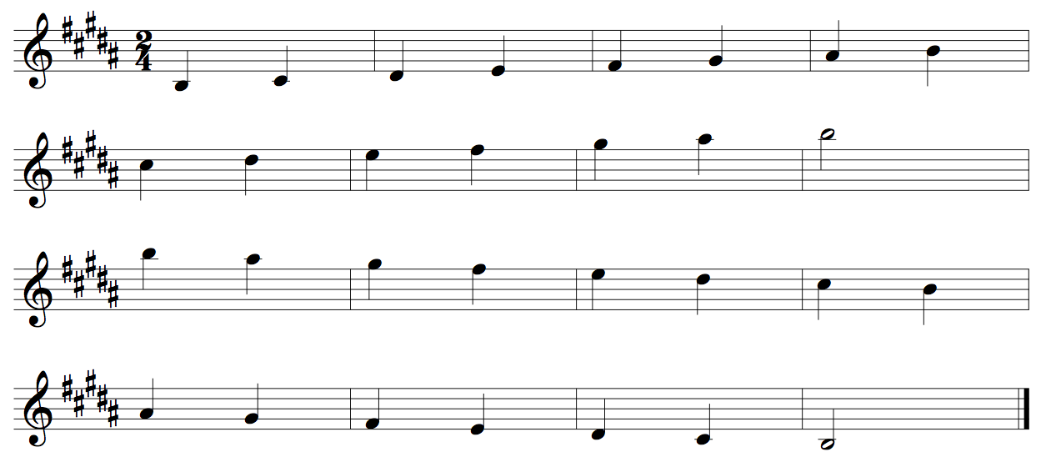
Xylophone Concert E Scale Two Octaves
Quarter Notes #24
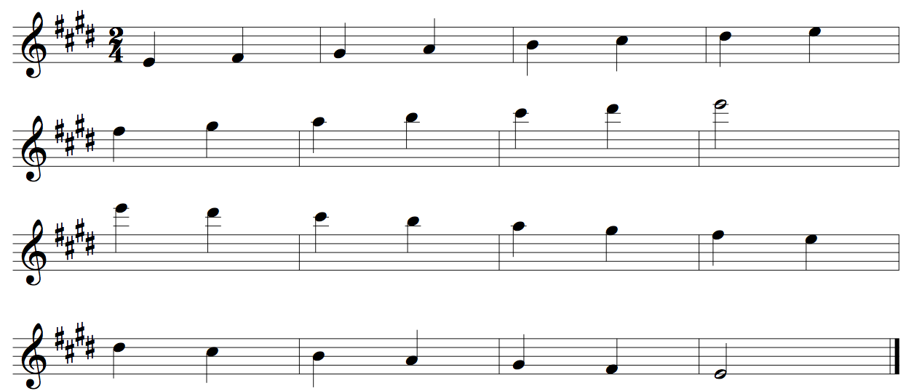
Xylophone Concert A Scale Two Octaves
Quarter Notes #24
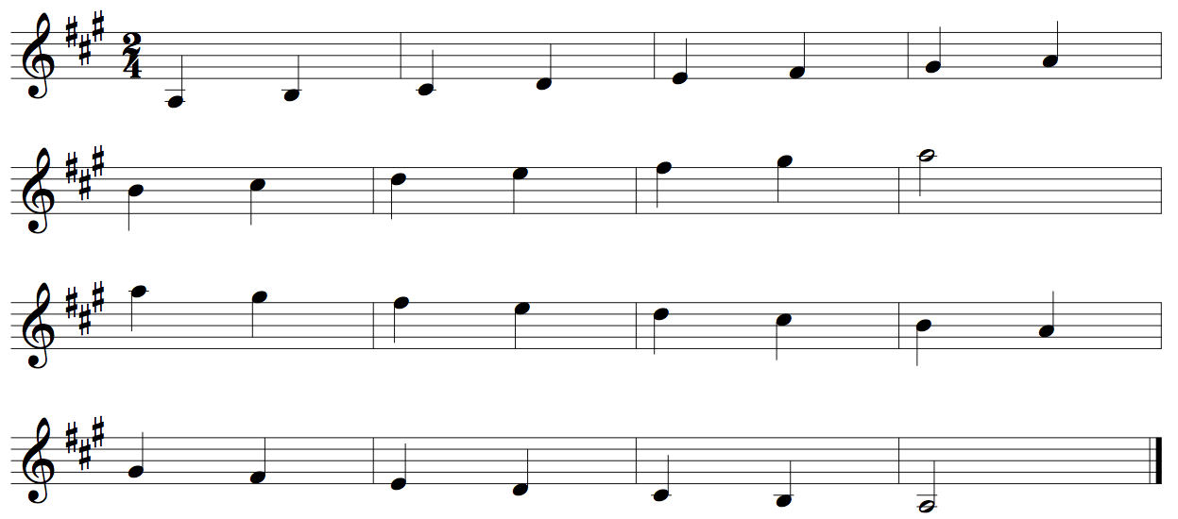
Xylophone Concert D Scale Two Octaves
Quarter Notes #24
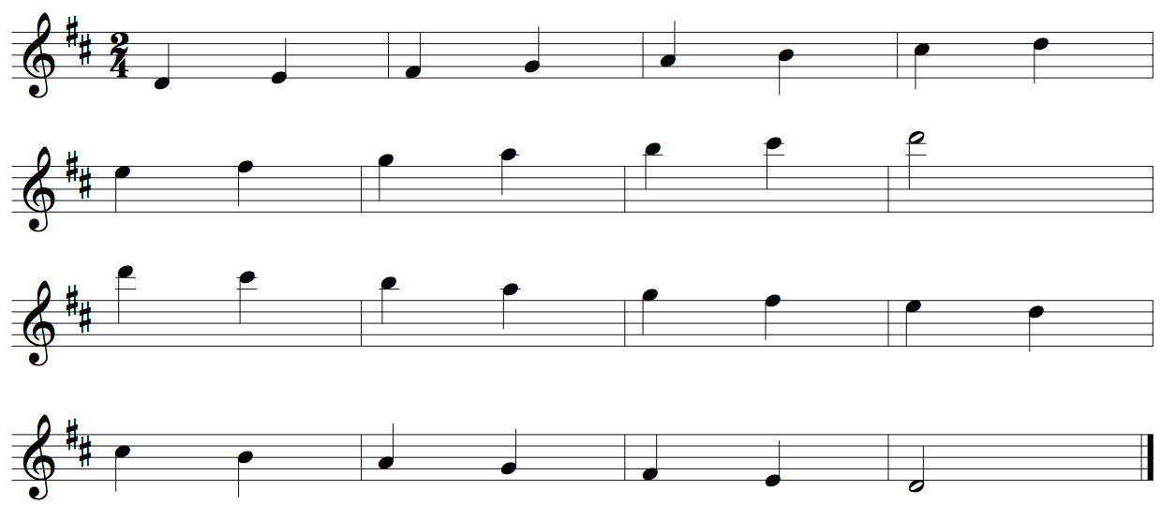
Xylophone Concert G Scale Two Octaves
Quarter Notes #24
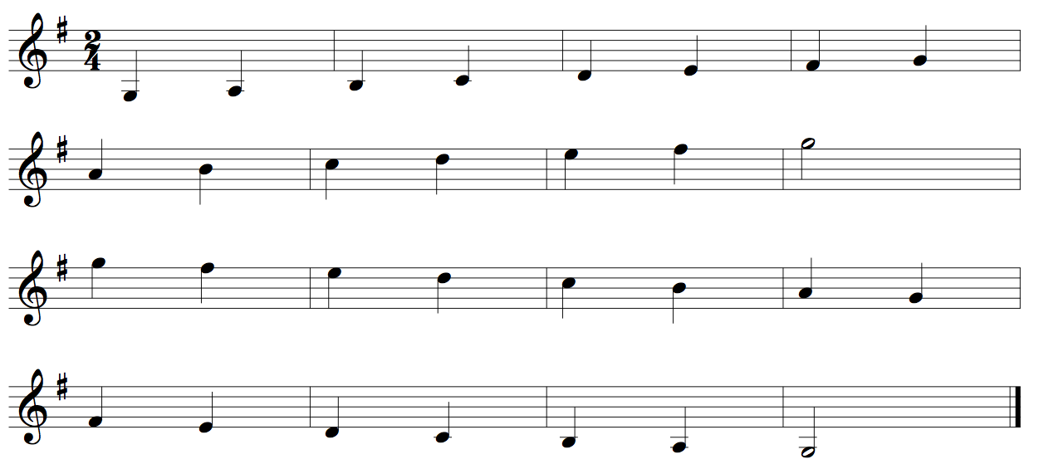
Xylophone Concert C Scale Two Octaves
Quarter Notes #24
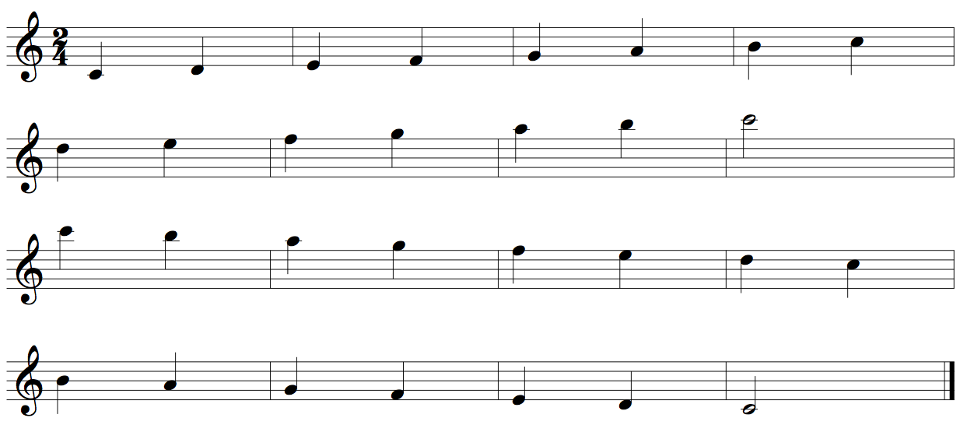
Xylophone Concert F Scale Two Octaves
Quarter Notes #24
